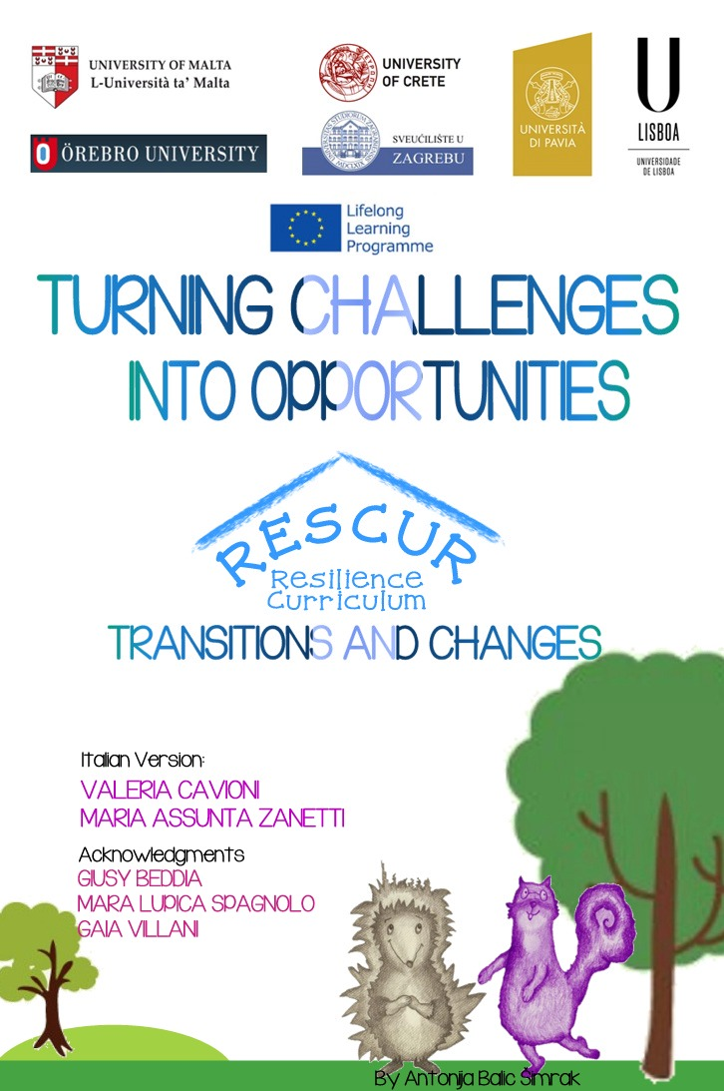

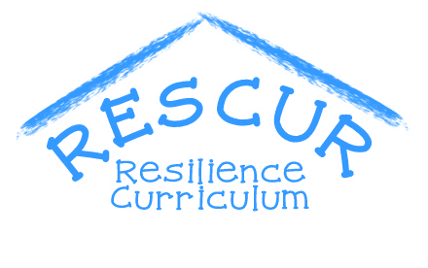
RESCUR IS A THREE YEAR LLP COMENIUS PROJECT (2012-2015) COORDINATED BY THE UNIVERSITY OF MALTA AND INCLUDING UNIVERSITY OF CRETE (GREECE), UNIVERSITY OF LISBON (PORTUGAL), OREBRO UNIVERSITY (SWEDEN), UNIVERSITY OF PAVIA (ITALY), AND UNIVERSITY OF ZAGREB (CROATIA).
IT IS AIMED AT DEVELOPING A RESILIENCE CURRICULUM FOR EARLY AND PRIMARY EDUCATION IN EUROPE THROUGH INTERCULTURAL AND TRANSNATIONAL COLLABORATION, TAPPING INTO THE RESOURCES AND EXPERTISE OF THE VARIOUS PARTNERS.
THE CURRICULUM WILL BE DEVELOPED ON THE BASIS OF THE CURRENT SOCIAL, ECONOMIC AND TECHNOLOGICAL NEEDS AND CHALLENGES OF THE PARTNERS INVOLVED, AND SEEK TO DEVELOP IN LEARNERS THE REQUISITE KNOWLEDGE AND SKILLS NEEDED TO OVERCOME SUCH CHALLENGES IN THEIR LIVES TO ACHIEVE ACADEMIC SUCCESS AND SOCIAL AND EMOTIONAL WELLBEING AS YOUNG CITIZENS IN THE EU.
IT WILL SEEK TO ADDRESS THE NEEDS OF VULNERABLE CHILDREN SUCH AS ROMA CHILDREN, CHILDREN WITH DISABILITY, GIFTED CHILDREN, AND CHILDREN OF REFUGEES, IMMIGRANTS AND ETHNIC MINORITIES.
THE CURRICULUM WILL BE PILOTED IN A NUMBER OF SCHOOLS IN EACH PARTNER COUNTRY AND THE FINAL PRODUCT INCLUDES MANUALS FOR SCHOOL TEACHERS AND PARENTS.

FOR FURTHER INFORMATION:
http://www.rescur.eu/ | for Italy: rescur.italy@gmail.com

SUMMARY
SUMMARY 3
FACING AND OVERCOMING TRANSITIONS AND CHANGES 4
LEARNING GOALS 4
ACTIVITY 1: Terry and her memories 6
ACTIVITY 2: It’s important for me 8
ACTIVITY 3: Changing means growing 10
ACTIVITY 4: Let’s start school! 13
ACTIVITY 5: New arrivals in family 16
ACTIVITY 6: the way to grow up 22
ACTIVITY 7: A step ahead! 38
ACTIVITY 8: How I was and how I am now 44
ACTIVITY 9: My future 48
References 52

FACING AND OVERCOMING TRANSITIONS AND CHANGES

LEARNING GOALS
By the end of this set, children will be able to
3-5 YEARS | - REFLECT ON THE AFFECTIVE / SYMBOLIC MEANING OF OBJECTS RELATED TO THEIR POSITIVE EXPERIENCES OF LIFE  - REFLECT ON THE SYMBOLIC MEANING OF OBJECTS IDENTIFYING ONE ITEM THAT IS EMOTIONALLY IMPORTANT WITHIN THE CLASSROOM  - FOCUS ON THE EXPERIENCE OF TRANSITION BETWEEN KINDERGARTEN AND PRIMARY SCHOOL ANALYZING POSITIVE AND NEGATIVE THOUGHTS AND EMOTIONS
6-8 YEARS | - REFLECT ON THE EXPERIENCE OF CHANGE RELATED TO THEIR FIRST DAY IN PRIMARY SCHOOL  - REFLECT ON CHANGES RELATED TO THE BIRTH OF A BROTHER / SISTER  - GIVE IMPORTANCE ON THEIR OWN PHYSICAL AND PSYCHOLOGICAL CHANGES THINKING OF THEMSELVES IN THE PAST, IN THE PRESENT AND IN THE FUTURE
9-11 YEARS | - REFLECT ON THE IMPORTANCE OF WELCOME THOSE PEOPLE FACED A BIG CHANGE DUE THE CONDITIONS OF IMMIGRANT  - TALK ON CHANGES OF THEIR LIFE FROM THEIR PAST TO THEIR PRESENT  - TALK ON CHANGES OF THEIR LIFE THINKING OF THEIR ASPIRATIONS AND DREAMS FOR THEIR FUTURE

.
THIS SET FACING AND OVERCOMING TRANSITIONS AND CHANGES AIMS TO PROVIDE AN OVERVIEW OF ACTIVITIES TO POSITIVLY SUPPORT EARLY CHILDHOOD TRANSITIONS.
A TRANSITION IS THE PASSAGE FROM ONE PLACE, STAGE, STATE, STYLE OR SUBJECT TO ANOTHER OVER TIME (DUNLOP AND FABIAN, 2002). FACING TRANSITIONS AND CHANGES SUCCESSFULLY IN CHILDREN’S LIVES PROVIDES OPPORTUNITIES FOR LEARNING AND GROWTH ON MULTIPLE LEVELS (DOCKETT & PERRY, 2007).
CHILDREN, IN PARTICULAR, DURING CHILDHOOD FACE MANY IMPORTANT CHANGES INCLUDING DIFFERENT LEARNING CONTEXTS, SOCIAL GROUPS, ROLES AND EXPECTATIONS THAT CAN BE FRIGHTENING FOR SOME CHILDREN AND CAN AFFECT THEIR SENSE OF PERSONAL IDENTITY AND SELF-ESTEEM (BREDEKAMP & COPPLE, 1997).
FROM THIS POINT OF VIEW, DEVELOPING RESILIENCE MEANS TO HELP CHILDREN TO DEAL WITH ADVERSITIES NAMELY ADAPTING TO CHANGES, SETTING NEW GOALS THAT REPLACE OLD GOALS THAT MAY BECOME INACCESSIBLE.
THE ABILITY TO ADJUST TO TRANSITIONS AND CHANGES INVOLVE BEHAVIORAL, COGNITIVE, AND EMOTIONAL ASPECTS OF THE DEVELOPMENT.
THIS SET OF ACTIVITIES FOCUSES ON ECOLOGICAL MODIFICATIONS (SUCH AS THE TRANSITION FROM KINDERGARTEN TO PRIMARY SCHOOL) AS WELL AS FAMILIAR CHANGES (SUCH AS THE TRANSITION TO SIBLINGHOOD) IN ORDER TO HELP CHILDREN TO DEVELOP THE SKILLS TO HANDLE CHANGES AND FACE TRANSITIONS SUCCESSFULLY BY UNDERSTANDING THEIR NEEDS AND THEIR STRENGTHS TO PROMOTE A POSITIVE PROCESS OF GROWTH.
ACTIVITIES WILL STRENGTHEN CHILDREN’S SKILLS TO REFLECT ON CHANGES AND TRANSITIONS AS PART OF LIFE; TEACHER WILL HELP STUDENTS TO POINT OUT HOW THEY HAVE CHANGED DURING THEIR LIVES AND DISCUSS WITH THEM HOW CHANGES AND CHALLENGES HAD AND CAN HAVE AN IMPACT ON THEIR LIVES, EXPECTATIONS AND MOTIVATIONS.

ACTIVITY 1: Terry and her memories
Learning goal
- The children will reflect on the affective / symbolic meaning of objects related to their positive experiences of life
Learning outcome
By the end of this unit, I will be able to:
- understand that I like some items (such as toys, photographs and other things that remind me of nice people and things in my life
Age: 3-5 years
Level: Basic
Materials: markers, sheets of paper, crayons, poster, glue
Activity
- Gathered in a circle, read to children the following story on "The boxes of memories" using puppets.

It was late afternoon and Zelda was bored. Daria, her sister, had gone to the grocery store with her mother. So Zelda was sitting on the couch with her dad. On television, however, there was nothing to see. So Zelda decided to go and visit the nearby Terry, a very nice skunk. Terry was very busy. On that day she had to help her parents to pack up for the move to her new tree!
Zelda wanted to help Terry pack up. But when she saw the packed boxes, she was curious to know what is inside. So, instead of closing the boxes, she was opening them to see what was inside. She saw photos of Terry’s family, clothes and toys. Zelda asked why they were keeping all those old items. Terry told her that all the objects reminded her of important memories. Now that Terry and her family needed to change tree, Terry was a bit scared about leaving her old tree home. She knew that she would find some new friends in the new school. But the photographs would help her to remember her old friends and the other skunks she knew to keep them in her heart forever.
- Use following questions to help children to understand the story:
- Did you like the story?
- Where did Zelda go?
- What was Zelda doing at Terry’s house?
- What did Zelda find inside Terry’s boxes?
- Then ask children:
- Have you got any toys, cloths, photographs that you Like a lot?
- Which items? Why?
- Do they remind you of anybody in particular or something that you did? If so, who and what?
- Let children share their memories and personal experiences.
- Ask children to make a drawing of the item previously mentioned.
- Help children to understand that it’s possible to keep memories of people or about positive experiences of the past that now are over also through items. Teacher can provide examples of her/his personal and professional memorabilia to help children. It’s important to underline that, for instance, photographs and other items can help to keep a memory of what happened in the past also in a difficult moment, like what happened to Terry.
- Collect all drawings of children in a poster taking notes of the affective and symbolic meanings of each item represented by children.

At home
At home, the children ask a parent to choose an object that, for him/her, it is important and the parent explains the meaning of the item for himself/herself. They make a drawing of the object asking a parent to write down motivations.

ACTIVITY 2: It’s important for me
Learning goal
- Children will reflect on the symbolic meaning of objects identifying one item that is emotionally important within the classroom
Learning outcome
By the end of this study unit, I will be able to:
- Understand that some things in my classroom may help me to remember people and other things that I enjoyed
Age : 3-5 years
Level: Intermediate
Materials: Poster, markers
Activity
- Start the activity reading the previous story “The boxes of memories”.
- Use the following questions to help children to understand the story:
- Did you like the story?
- Where did Zelda go?
- What was Terry doing ?
- What did Zelda do then?
- What did Zelda find inside the boxes?
- How did Terry feel? Why?
- In your opinion, why was it important for Terry to keep those items?
- Ask children to reflect on Terry’s move thinking that all kept items will be useful for her to remember all positive experiences with her friends.
- Organize a game with children: ask them to identify an object within the classroom that they consider important explaining also the reasons. Give them enough time to explore every corner of the classroom before choosing an object. Explain to them that the selected object can be a toy and also any other kind of item; the most important thing is that they have to be able to explain why they chose it and which memories it brings to their mind.
- At the end, children can show the selected object to the classmates explaining their reasons behind their choice.
- The teacher takes notes of children’s comments on a poster.

At home
At home children can ask their parents to choose an object that is in their house which is especially important for them. Parents can explain to children the reasons for that choice. Children make a drawing of the object identified by parents

ACTIVITY 3: Changing means growing
Learning goal
- Children will focus on the experience of transition between kindergarten and primary school analyzing positive and negative thoughts and emotions
Learning outcome
By the end of this study unit, I will be able to:
- Become a bigger and better boy/girl as I start primary school
Age: 3-5 years
Level: Advanced
Materials: worksheet “Terry changes tree”, poster, pencils, markers
Activity
- Gather the children in a circle, read them the story “The boxes of memories” (activity 1) using hand puppets or finger puppets
- Use the following questions to help children to understand the story:
- Did you like the story?
- Where did Zelda go?
- What was Zelda doing?
- What did Zelda find in the boxes?
- In your opinion, how did Terry feel? Why?
- Ask children to fill the “Terry changes tree” worksheet trying to identify the path that Terry has to do to arrive at the new tree.
- At the end of the activity, after each child identified the correct path, ask them to reflect on Terry’s move. She will face a big change like what children will face next year, moving from kindergarten to primary school.
- Deepen these aspects asking them:
- Have you ever thought of how it will be next year in the first class?
- Is there anything that makes you happy when you think about next year?
- Is there anything that makes you worried when you think about next year?
- Collect all ideas on a poster and, together with children, focus on which strategies they can use to face worries they have on the transition to primary school. It’s important that the teacher accepts all children’s worries in order to share their emotional experiences and, together with children, seek for some shared solutions to overcome those difficulties and worries.
At home
Children at home ask parents to tell them about their first day at school. Children then make a drawing of it.

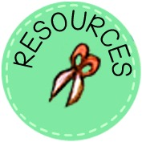

TERRY CHANGES TREE
HELP TERRY TO FIND THE WAY TO ARRIVE AT HER NEW TREE
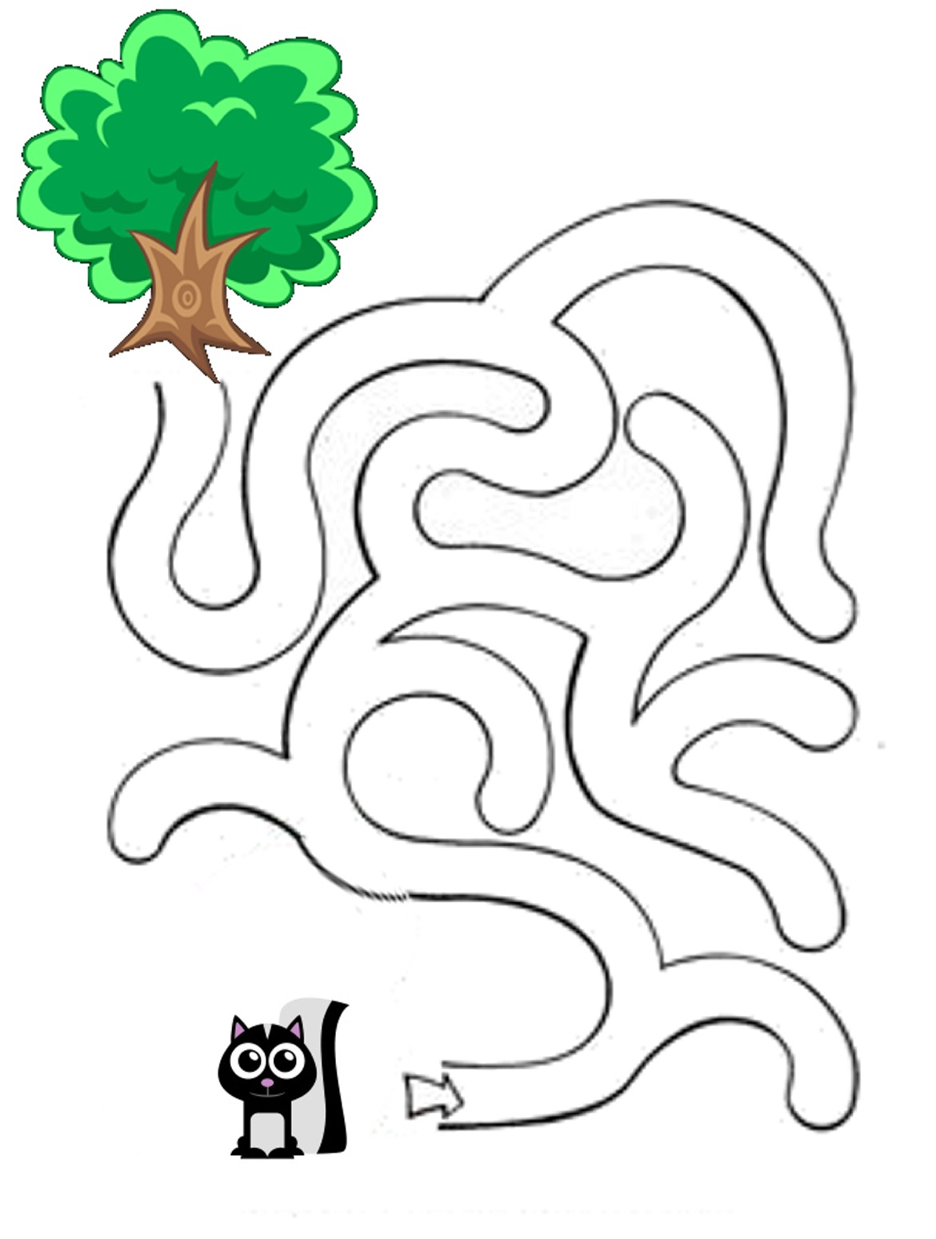

ACTIVITY 4: Let’s start school!
Learning goal
- Children will reflect on the experience of change related to their first day in primary school
Learning outcome
By the end of this study unit, I will be able to:
- Talk about the changes I faced when I started primary school
Age : 6-8 years
Level: Basic
Materials: Worksheet “My first day at school”, pens and/or markers, poster
Activity
- Start the activity reading the following story “Gina the little turtle”.

That day at school was a special day because in Zelda’s class a new animal joined the class. This was Gina, the little turtle. Gina used to live in from the Slow Forest. In her forest everything was slow, the water flowed slower, the animals were moving slowly and the trees grew slowly. When Gina moved to Zelda’s forest, she found a big change. She was used to have a very different and slower life style! Here, at school, everyone was running. She felt unsafe and really lonely! She missed her old school, her classmates and her beloved teacher. Zelda’s teacher noticed that Gina was uneasy. She thought, then, that Gina needed help to make friends with her new classmates. Zelda was ready to run outside. But the teacher asked her if she could stay near Gina, became her friend and play with her.
“I don’t know her, I want to play outside in the river, I don’t like to waste time,” said Zelda.
"Zelda, remember how you felt the first day of school, when you did not know anyone. Gina needs everyone's help to deal with this change. We all need to help her get through this difficult time," replied Zelda’s teacher.
Zelda thought a bit on it and then she understood that her teacher was right. Zelda went to Gina and they started playing together. Although Gina was slower than her, she was really nice and, with her carapace, she could float very well in the river. They spent the whole afternoon together swimming and laughing.

- Use the following questions to help children to understand the story:
- Did you like the story?
- Who arrived in Zelda’s class? From where?
- In your opinion, how did Gina the little turtle feel at the beginning?
- What did the teacher ask Zelda to do?
- What happened then?
- In your opinion, how did Gina the little turtle feel after she met Zelda?
- In your opinion, which was the most difficult challenge for Gina the little turtle? Why?
- Teacher asks children to recall their first day in the first class in primary school questioning them:
- Did you remember about your first day at school?
- How did you feel? Did you feel scared? Can you explain what you were afraid of?
- Who took you to school?
- Did you like the first day at school?
- Ask children to motivate their answers and let them share their experiences.
- With the support of the “My first day at school” worksheet, children respond about: 1) what they thought; 2) how they felt; 3) what they said to others; 4) what they needed– during the first day at school. Teacher may help children to fill the worksheet giving some examples.
- At the end, teacher collects all ideas on a poster summarizing all contents and underlining that the first day was an important day in the life of everybody. They had to face a number of changes and difficulties that they were able to cope also with the help of others.
At home
At home children interview parents about their first day at school filling the same worksheet completed at school “My first day at school” describing thoughts and emotions of their parents.

MY FIRST DAY AT SCHOOL
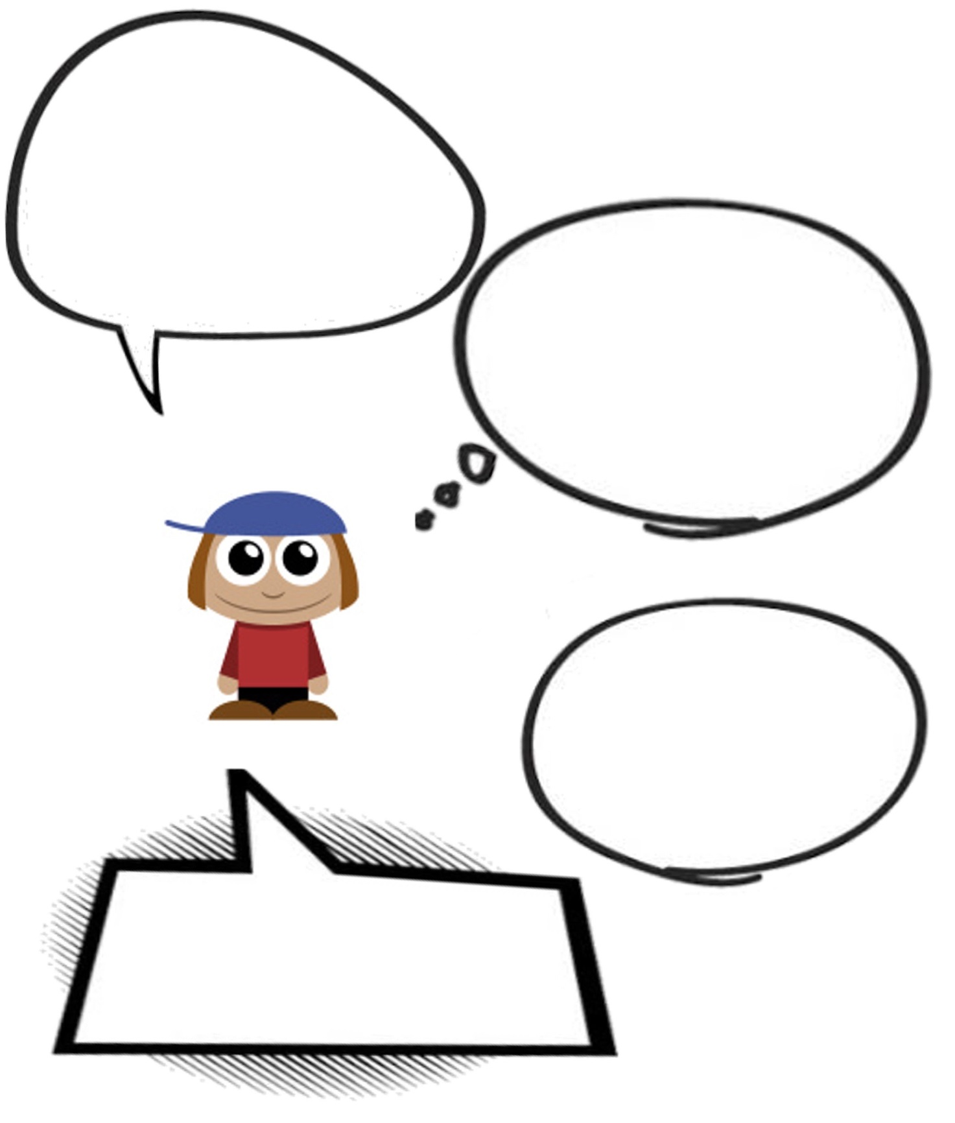
I FELT…
I NEEDED….
I THOUGHT…
I SAID…

ACTIVITY 5: New arrivals in family
Learning goal
- Children will reflect on changes related to the birth of a brother / sister
Learning outcome
By the end of this study unit, I will be able to:
- Understand and see the changes related to the birth of my brother/sister as a way to grow into a bigger boy/girl
Age : 6-8 years
Level: Intermediate
Materials: Poster, pictures of families, markers
Activity
- Read the previous story “Gina the little turtle”
- Use the following questions to help children to understand the story:
- Did you like the story?
- Who arrived in Zelda’s class? From where?
- In your opinion, how did Gina the little turtle feel at the beginning? What happened then?
- In your opinion, which was the most difficult challenge for Gina the little turtle? Why?
- Introduce the topic of the change explaining to children that Gina the little turtle had to face a big change, namely change place to life, school and friends. The activity that children are going to do will help them thinking of a kind of change that maybe somebody will face or they have already faced.
- With the help of images “Pictures of families”, invite children to carefully observe all images and identify which can represent their own families. Children may identify one or more images and, if there are no pictures that can represent their family, they can choose the closest ones specifying which changes they would make to them.
- Let children describe motivation of their choices and all members of their families.
- Choose, between the images previously selected by the children, those who represent a family where there are brothers and/or sisters and ask children (who have brothers / sisters):
- Does anyone have brothers / sisters children? Do you remember what he/she was born?
- Did your parents tell you how you behaved towards your brother / sister when you were a baby child?
- Guide the discussion deepening memories of children towards their brothers/sisters both younger and older than them. Let those who have no brothers/sisters to explain their opinions and emotions engaging them in the discussion and asking if they have ever thought how it would be to have brothers / sisters.
- Collect all thoughts, life’s experiences and emotions on a poster underlining, if referred by children, that the birth of a brother/sister represents a big change for all family members.
At home
At home children interview an adult that has brother/sister to collect a positive and a negative life’s event of his/her childhood shared with his/her brother/sister.

PICTURES OF FAMILIES

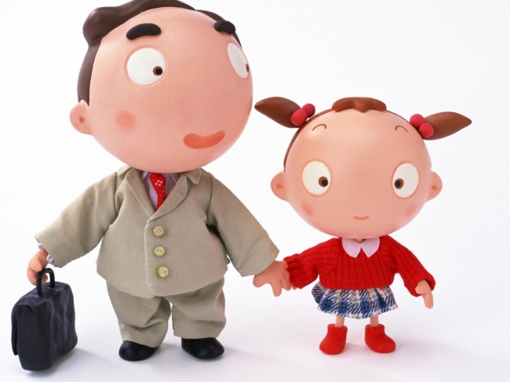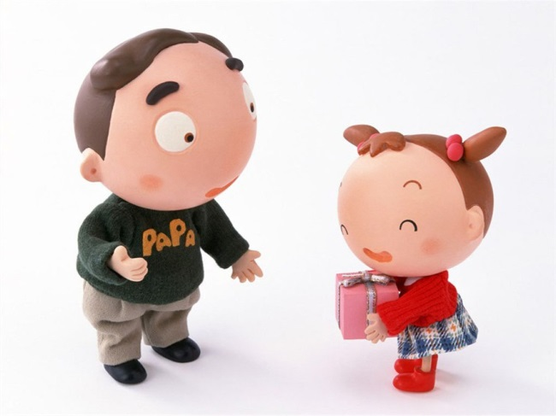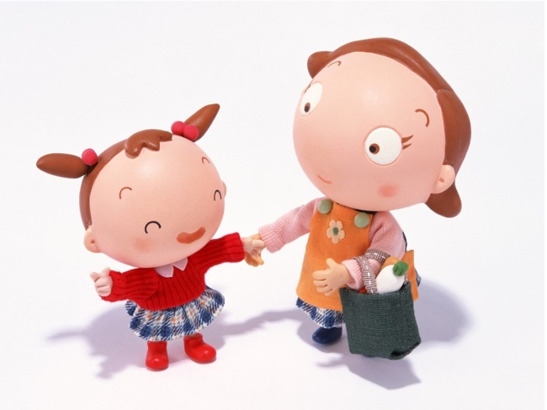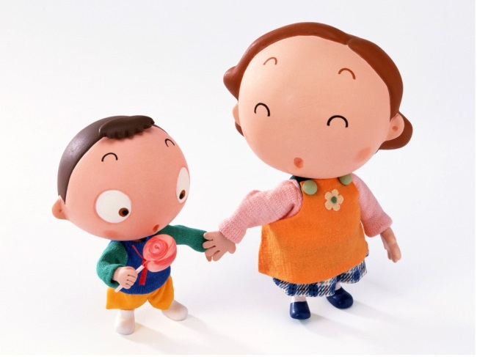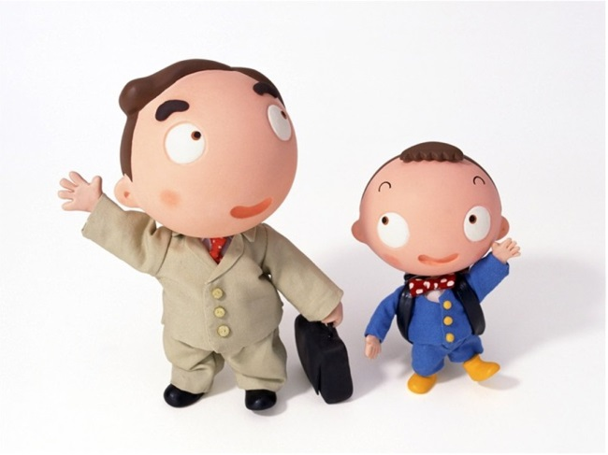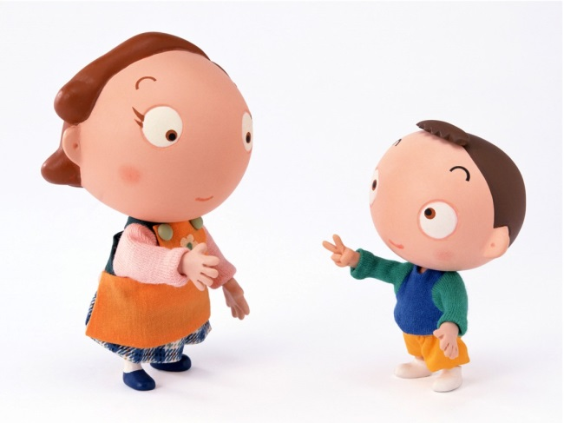

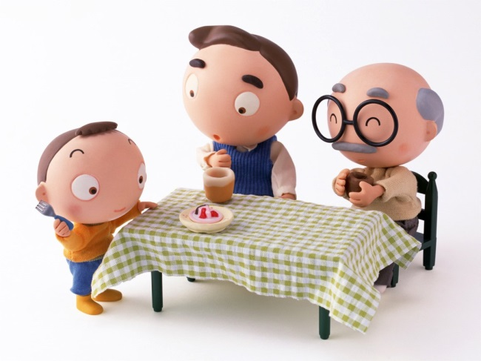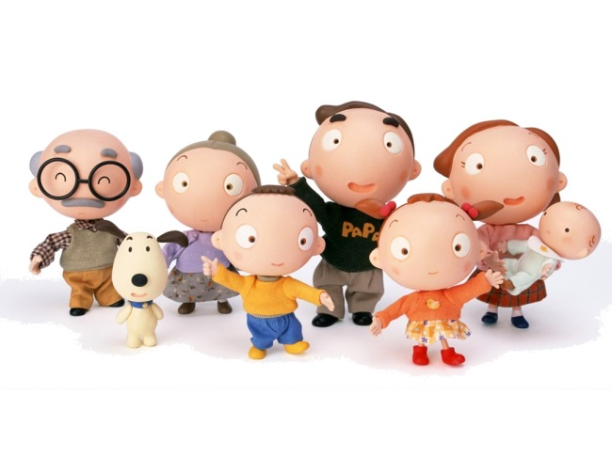
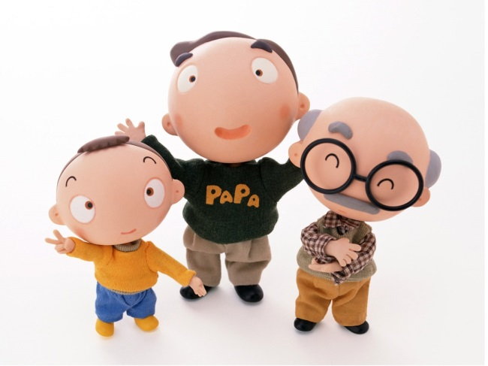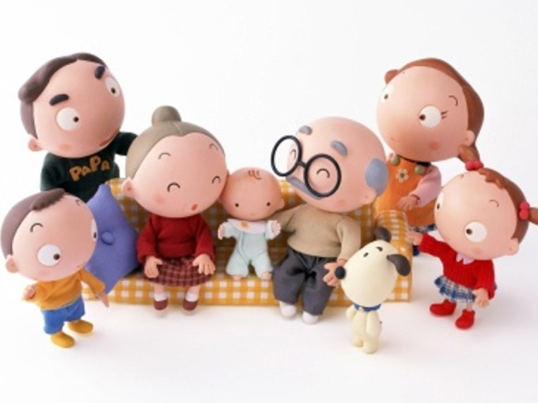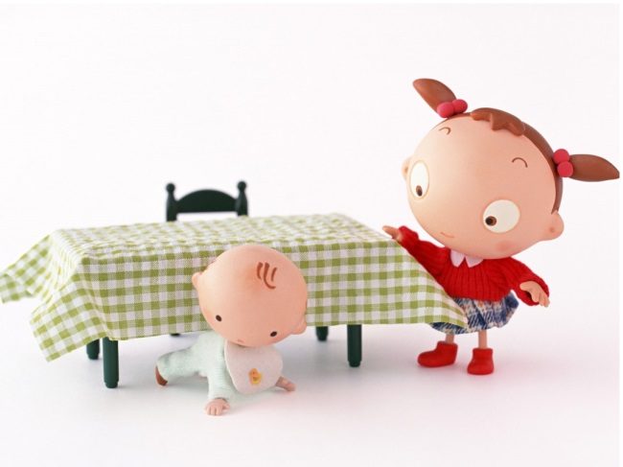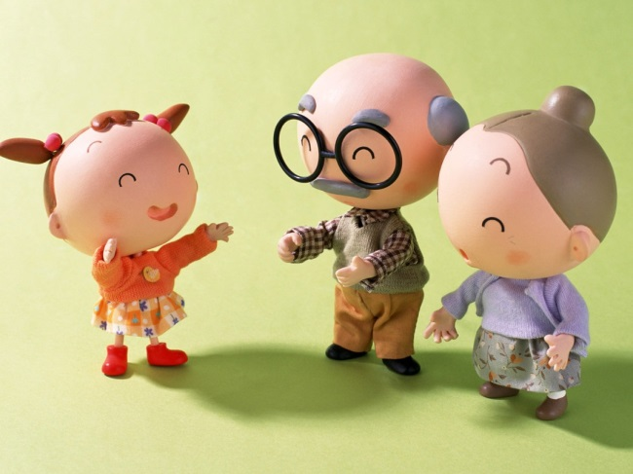

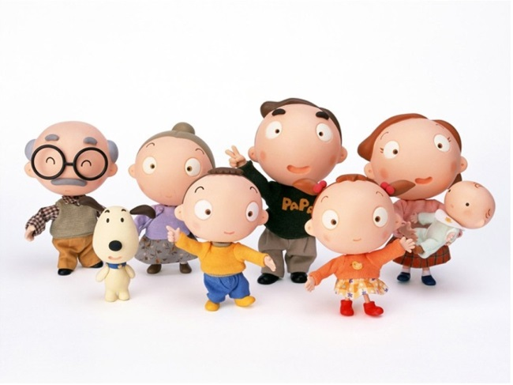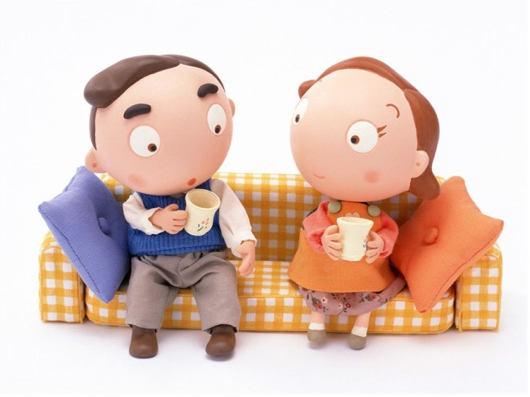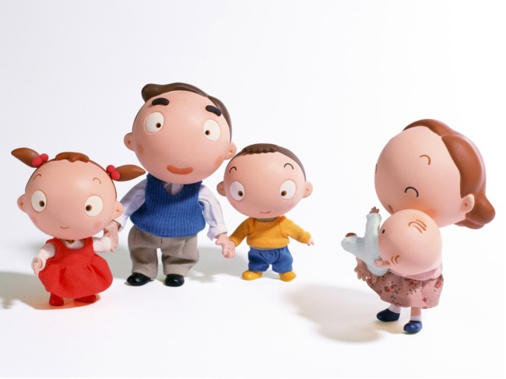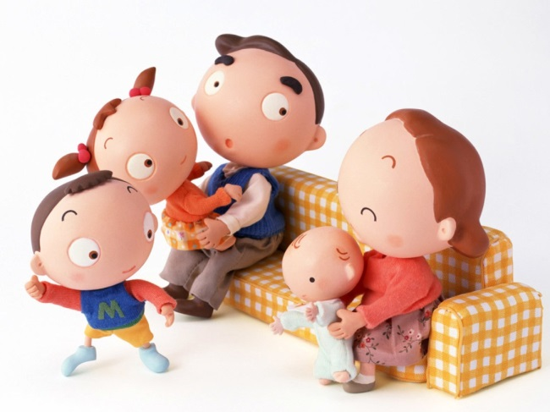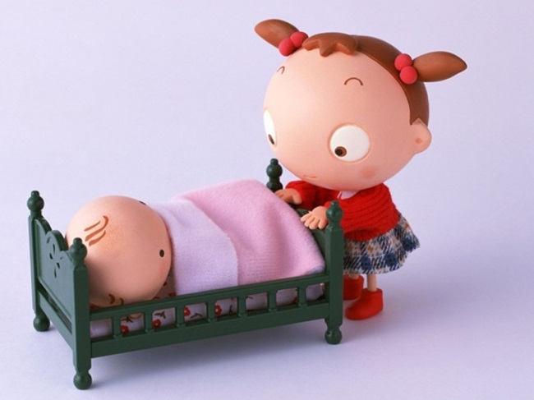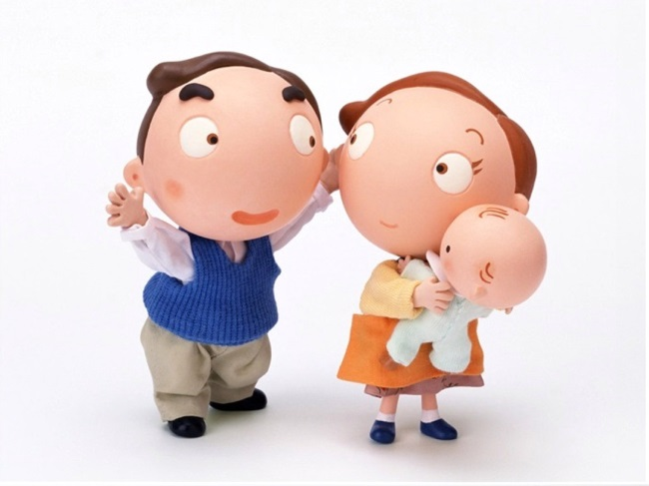

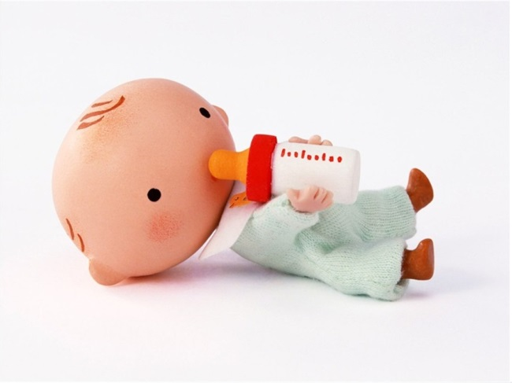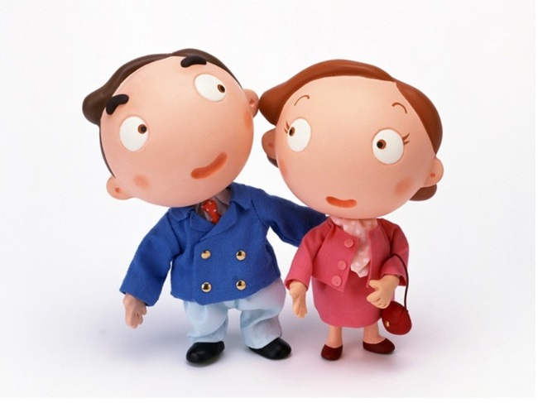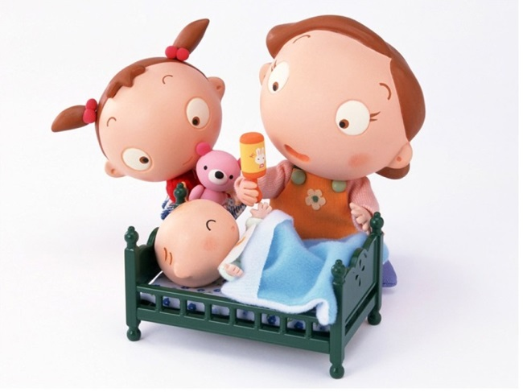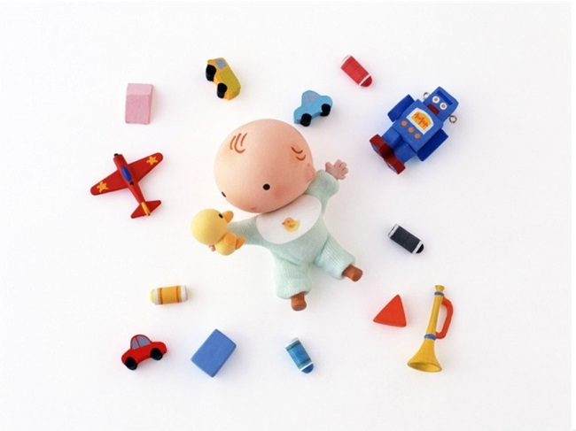

ACTIVITY 6: the way to grow up
Learning goal
- Children will understand their own physical and psychological changes thinking of themselves in the past, in the present and in the future
Learning outcome
By the end of this study unit, I will be able to:
- Understand the physical and psychological changes in my life thinking of myself in the past, in the present and in the future
Age : 6-8 years
Level: Advanced
Materials: images “Picture of Life”, poster, markers
Activity
- Begin the activity reading the story " Gina the little turtle" (activity 4)
- Use the following questions to help children to understand the story:
- Did you like this story?
- Who arrived in Zelda’s class?
- How did Gina the little turtle feel, in your opinion, at the beginning?
- How did Gina the little turtle feel, in your opinion, after she met Zelda?
- In your opinion, which was the biggest difficulty for Gina the little turtle? Why?
Starting from the children’s answers, explain that Gina the little turtle had to face a number of changes and / or difficulties. To better understand these aspects, children will do the following game.
- Start the game placing all the images "Pictures of Life" cut out on the floor of the class (or in the gym) in order to arrange them in lines and children can see them easily walk between them afterwards.
- Gathered in a circle, ask children to start thinking about themselves in the present. The first request is to choose an image from those on the floor to represent them in the present. The teacher can decide whether to duplicate some images where the same or more children choose them or to add extra images.
- Encourage children to choose another image to represent themselves in the past.
- After children also made this choice, they choose the last image representing themselves in the future. It is important that each student has enough time to walk across images placed on the floor to see them all.
- When everybody has three images of the past, present and future, children can come back gathered in a circle.
- The teacher invites children to show the three selected images to classmates explaining the reasons for the choices. Some children, with the help of images, will describe some changes related to growth; it is important, however, that the teacher helps children to understand the changes of their life not only in terms of physical development but also psychological changes. The teacher can ask some questions:
- Related to those images you selected, how did you change since when you were younger up to today?
- How would you like to be in the future?
- Teacher collects all comments on a poster underlining the meaning of change in their life and challenges and transitions that they coped with successfully.
- The teacher should be ready to hear also some comments about adverse consequences suffered by some children through changes in their family. In such situations, the teacher can help the child to reframe the experience as having been difficult but that through it the child learned how to deal better with life: such as having to share toys leading to being more able to build friendships.

At home
Children at home, with the help of parents, make a collage using words, texts, pictures and photographs to represent the concept of "growth" reflecting on what it means growing themselves. Students can represent the concept with contents and materials they prefer
PHOTOS OF LIFE

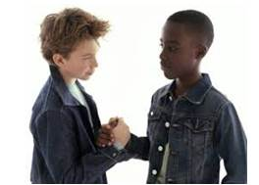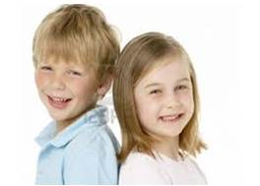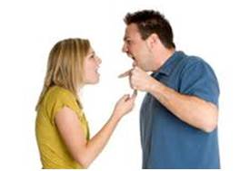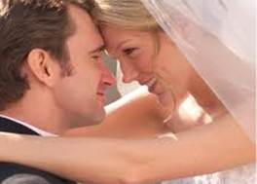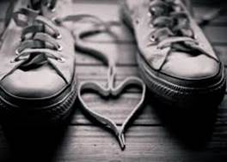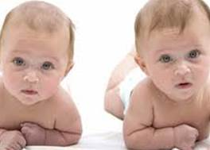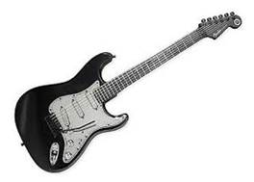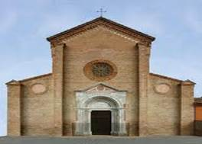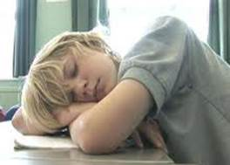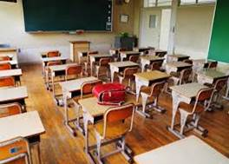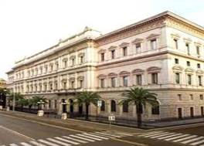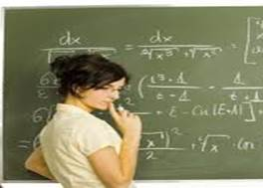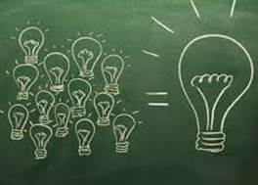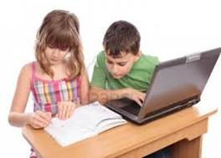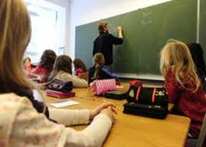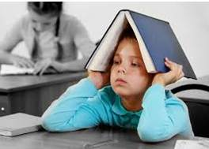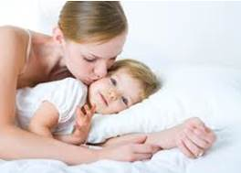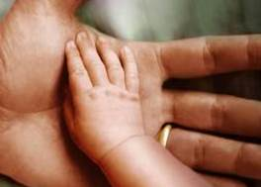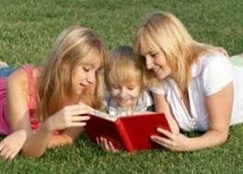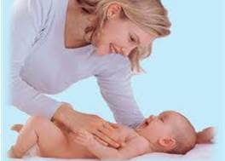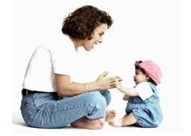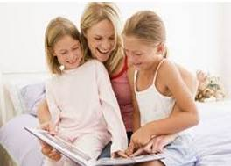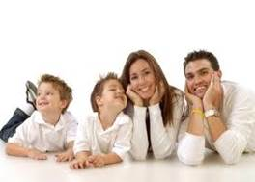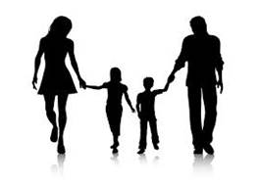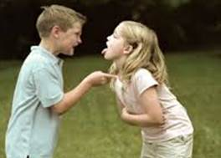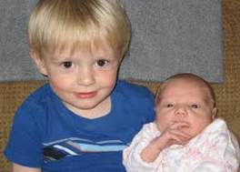
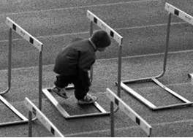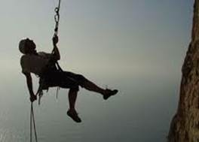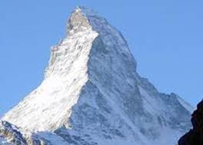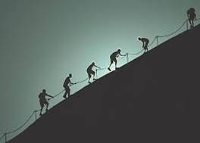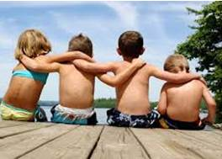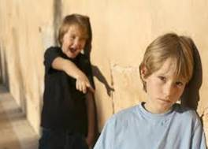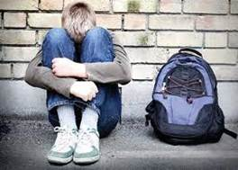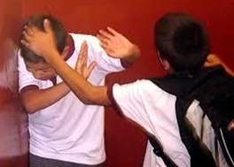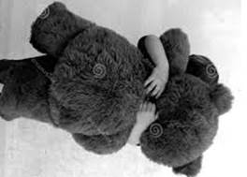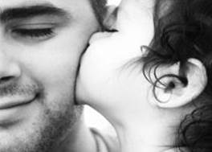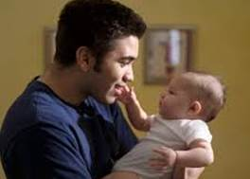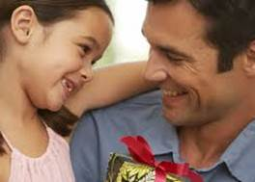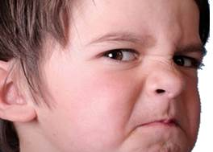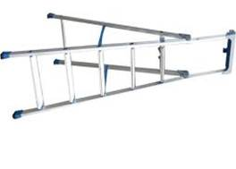
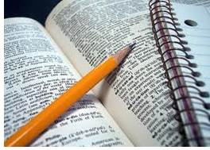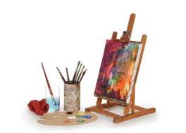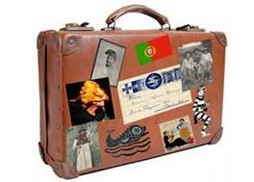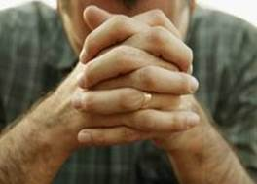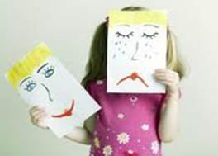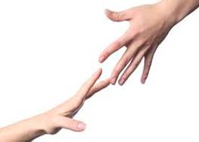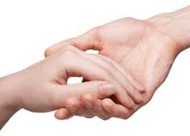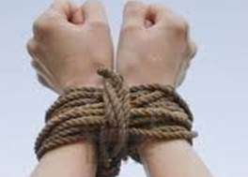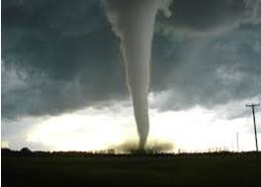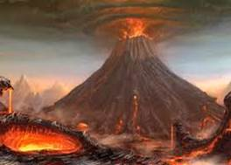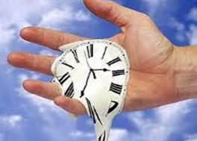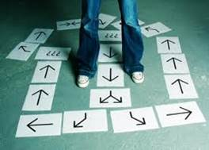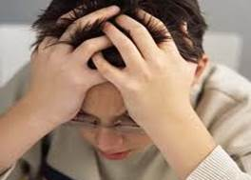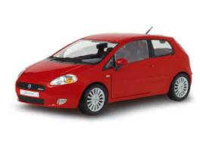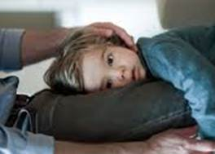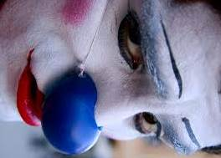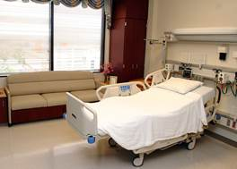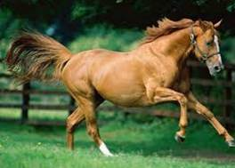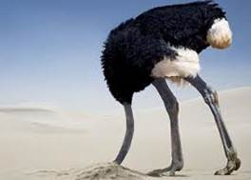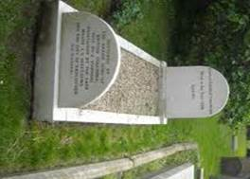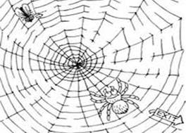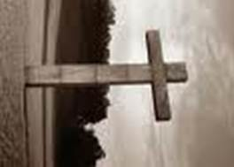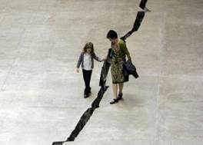

ACTIVITY 7: A step ahead!
Learning goal
- Children will reflect on the importance of welcome to those people who faced a big change due to immigration
Learning outcome
By the end of this study unit, I will be able to:
- Understand difficulties of people who change home and school because of migration
Age : 9-11 years
Level: Basic
Materials: sheets of papers, poster, markers, pens

Activity

- Start the activity reading the following text “Ismael’s trip”.

Ismael was a Palestinian guy who had just graduated in History at the University of Bethlehem. His parents lived in a small village in the Gaza Strip, a territory bordering Israel and Egypt. Due to the armed conflicts that were ravaging the villages of that area, Ismael and his family had to take a painful but inevitable decision. They decided to leave the war zone and emigrate to another safer place.
Ismael, during the university years, had many friends. One of his best friends was Patrick, a British guy that, after university, went back home to England. As soon as Patrick knew that Ismael’s family was looking for a place to emigrate, Patrick immediately offered his house and so Ishmael and his family made a long trip, crossing many states to reach England.
Ismael did not know English very well. So he had a lot of difficulties communicating with people and he was missing his friends and his country. Every now and then he was very sad because after many years of study the thought he would become a professor of history in Palestine, he felt instead he lost everything and he was not being able to do anything in this new Country. He felt different and isolated because he was speaking another language and he was an immigrant in this Country.
Patrick and his family understood the difficulties of Ismael and his family. Therefore they welcomed them into their home and they helped them to learn their language. Finally, one day, Ismael managed to get a job as a teacher of History in a primary school. His dream at last became true. He was a very good teacher and also he could teach also his history, and the history of his country. He spoke to his students of the difficulties encountered when somebody migrates to a country and how it’s important to welcome and help others.

- Use following questions to better understand the story:
- Where did Ismal live?
- What did Ismael use to study?
- What did Ismael want to become?
- Why did Ismael and his family move to England?
- Who helped Ismael and his family? How?
- In your opinion, how did Ismael and his family feel when they arrived in England?
- In your opinion, how did Patrick and his family feel when they hosted Ismael and his family?
- What happened to Ismael at the end?
- Divided in groups, ask children to think about other ways to help Ismael and his family and write their ideas on sheets of papers. They can write a new part of Ismael’s story, or make a drawing to show their ideas.
- At the end, let the children share their ideas.
- Collect all ideas on a poster summarizing strategies to help those who faced a big change like moving from one country to another in a condition of immigrant.

At home
At home, children with parents, play the game of Famous immigrants " reading the stories of some famous people who emigrated from their country to seek success in another state. Children try to match each story to the name and photo of the character. This game is intended to help children to understand that being an immigrant means to face challenges, but, being resilient, it’s still possible to achieve personal goals and successes. Some characters may be more well-known than others. In the box below solutions for the combinations are provided.
Solutions:

Name | Photo | Story
Albert Einstain | D | N. 3
Bob Marley | B | N.1
Arnold Schwarzenegger | A | N. 4
Jim Carrey | C | N. 2

ALBERT EINSTEIN

BOB MARLEY

ARNOLD SCHWARZENEGGER

JIM CARREY

STORY N. 1
Born in a small village in Jamaica, in 1945 from a British father and a Jamaican mother, he moved with his family to the capital of Jamaica seeking for better life. At age 15, he had to leave school and he started working as a welder. He began to love music and singing, he founded a band and he played around the world. His music and lyrics focus on the theme of the struggle against political oppression and racial discrimination to achieve freedom and equality. In 1978 he was awarded the Medal of Peace by the United Nations. Today is the symbol of reggae music genre, and his hair "Rasta" is his symbol of recognition of his talent as a songwriter and guitarist.

STORY N. 2
.
Born in 1962 in a city near Toronto, in Canada, he started his acting career when he was child (at 10 years). Even his teachers were aware of his talent, and every day after school, they let him put up a funny show. His family faced financial problems and they even had to live in a van for some time.
At 16, he decided to pursue a career as a comedian. He moved to the United States where he began to take small parts in movies. He became a US citizen. His quirky and funny characters made him famous all over the world especially in the role of Ace Ventura, the Pet Detective, a private investigator that was specialized in finding animals. He also took part in the movie "The Mask". Today he is known not only as an actor but also as a voice actor and producer not only for comic but also dramatic roles.

STORY N. 3
He was born in Germany in 1879 from a Jewish family. From an early age, was attentive and curious towards the world even though he did not like school a lot. Due to some financial difficulties, his family had to move often, first to Monaco, then to Italy and then to Switzerland. In 1933 he had to move to the US because of anti-semitic persecution in Germany. There, he became a professor at Princeton University, but during this time he faced many difficulties: he was severely discriminated against for his Jewish roots. To survive, he had to give up German and Switzerland citizenship and become a citizen in the US. Today he is known for his research and books about the understanding of the world in the study of Physics, and in 1921 he received the Nobel Prize for Physics. He is famous around the world for the theory of relativity and he is a symbol of intelligence and talent

STORY N. 4
Born in 1947 in a small Austrian town from a very poor family, he was passionate about sport since he was a young man. He also won several competitions in weightlifting. After moving to Monaco and Munich seeking fortune, he opened his own gym but had to close it due to financial problems. After winning a very important award as bodybuilder, he was finally able to move to London and then to the United States. He built his career on his image of physical strength and on his muscular physique. Among the most famous film, he is famous for the interpretation of the barbarian warrior “Conan” and “Terminator” robot-humanoid. In 2003 he was elected Governor of the State of California. His political activity has been devoted to face racism, pollution and global warming. He is considered to be one of the hundred most influential people involved to help the world.

A | B  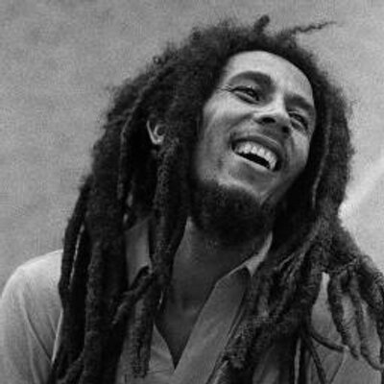
C | D  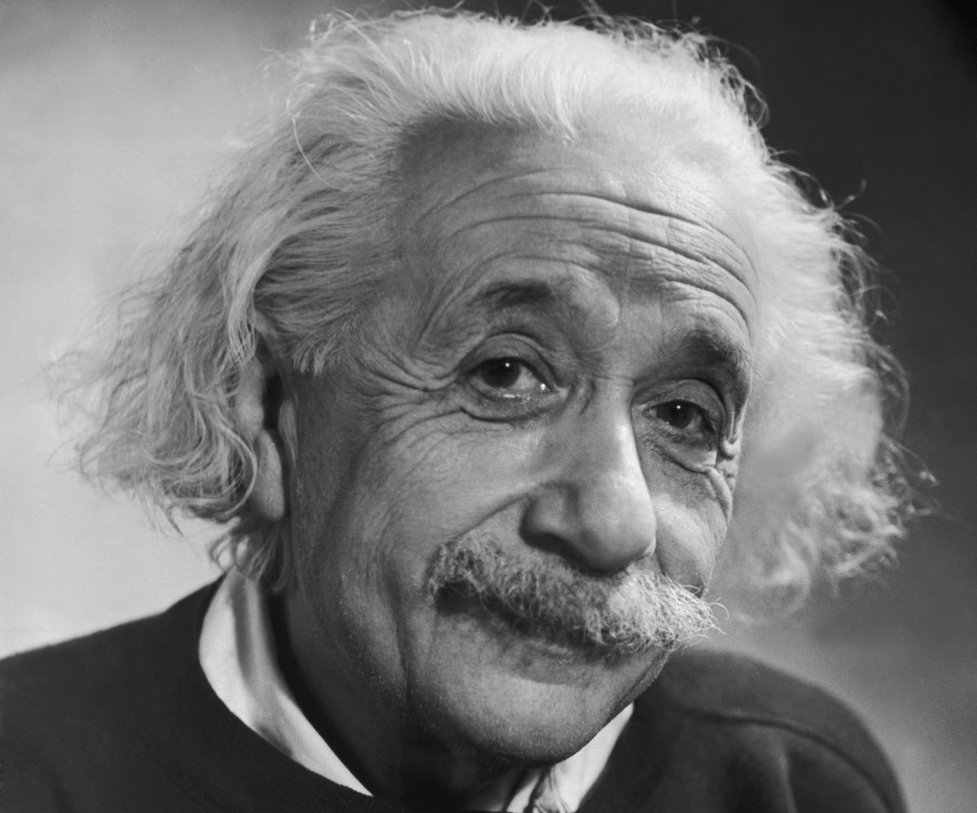

ACTIVITY 8: How I was and how I am now
Learning goal
- Children will talk about changes of their life from their past to their present
Learning outcome
By the end of this study unit, I will be able to:
- narrate changes of my life from the past to the present
Age : 9-11 years
Level: Intermediate
Materials: worksheet “I was… I am”, crayons, markers
Activity
- Start the activity showing children the worksheet “I was…I am” and asking them, at the beginning, to think about how they were when they were attending the first class in primary school.
- On the top part of worksheet, children can describe themselves or make a drawing on what they remember of themselves in the first class.
- Next, the teacher asks children to fill the other part of the worksheet making a drawing or writing about how they think about themselves in the present.
- At the end, gathered in a circle, each child can share what he/she wrote or drew.
- The teacher, with the help of the following questions, can deepen the topic of the activity:
- Did you change over these last years?
- How?
- Can you describe your physical changes?
- Can you describe how your character changed?
- How are you better now than before? How do you think you grew up?
- On a poster, teacher can collect all answers emphasizing the significance of growth for children.

At home

At home, with the help of parents, children complete the worksheet "Present-Future" reflecting on their wishes and aspirations for the future and what they can do to achieve those goals.

I WAS…I AM
WRITE BELOW HOW YOU WERE A FEW YEARS AGO WHEN YOU WERE IN THE FIRST GRADE OF PRIMARY, AND HOW YOU ARE NOW. THINK ABOUT THOSE THINGS ABOUT YOU THAT HAVE CHANGED OVER THE PAST FEW YEARS.
FIRST I WAS …
NOW I AM …

PRESENTFUTURE
WHAT ARE YOU GOING TO DO WHEN YOU GROW UP? WITH THE HELP OF A PARENT, WRITE IN THE FORM BELOW WHICH “STEPS" YOU NEED TO DO TO MAKE YOUR FUTURE
-----------------------------------------------------------------------------------------------------------------------------------------------
-----------------------------------------------------------------------------------------------------------------------------------------------
-------------------------------------------------------------------------------------------------------------------------------------------------------------------------------------------------------------------------------------------------------------------------------------------------------------------------------------------------------------------------------------------------------------------------------------------------------------------------------------------------------------------------------------------------------------------------------------------------------------------------------------------------------------------------------------------------------------------------------------------------------------------------------------------------------------------------------------------------------------------------------------------------------------------------------------------------------------------------------------------------------------------------------------------------------------------------------------------------------------------------------------------------------------------------------------------------------------------------------------------------------------------------------------------------------------------------------------------------------------------------------------------------------------------------------------------------------------------------------------------------------------------------------------------------------------------------------------------------------------------------------------------------------------------------------------------------------------------------------------------------------------------------------------------------------------------------------------------------------------------------------------------------------------------------------------------------------------------------------------------------------------------------------------------------------------------------------------------------------------------------------------------------------------------------------------------------------------------------------------------------------------------------------------------------------------------------------------------------------------------------------

ACTIVITY 9: My future
Learning goal
- Children will talk about the changes they will undergo in their life to reach their aspirations and dreams for their future
Learning outcome
By the end of this study unit, I will be able to:
- talk about the changes I will go through in my life as I build my future
Age: 9-11 years
Level: Advanced
Materials: “My future” icons, poster, crayons
Activity
- Begin the activity showing the children, gathered in a circle, the icon "My future".
- Ask the children to think of themselves in the future and to choose three icons that represent their own future. In the event that some children have difficulties in finding a suitable icon, they can choose to draw a new one.
- When each child has chosen an icon/s, the teacher invites the children to show the icons to classmates explaining the reasons for their choice by asking them:
- Looking at the icons you chose, how do you think your future will be?
- In your opinion, which difficulties you will have to face in order to achieve the goals that you have described?
- Which are your skills and your talents that you think will help you to reach the goals you have described?
- The teacher collects all the ideas on a poster.

At home
At home, children ask parents to describe a time in their lives when they faced a difficulty to achieve a goal that they considered important, describing how they overcame that difficulty. Children can draw a picture or write down the story.

“MY FUTURE” ICONS

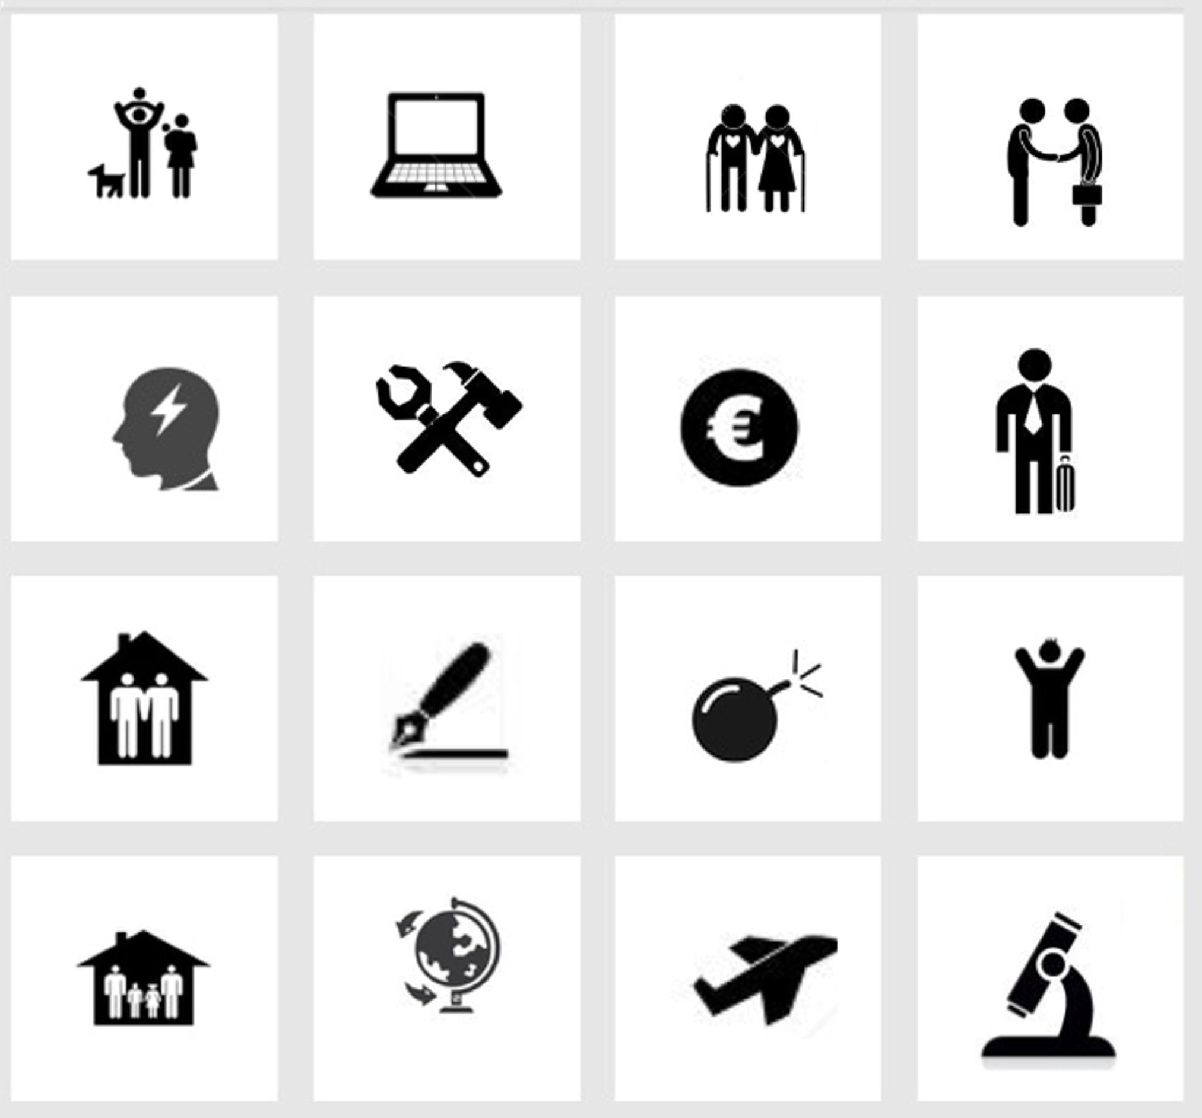

References
Bredekamp, S., & Copple, C. (Eds.) (1997). Developmentally appropriate practice in early childhood programs (Rev. ed.). Washington, DC: National Association for the Education of Young Children
Dockett, S., & Perry, B. (2007). Transitions to School. Perceptions, expectations, experiences. Sydney: UNSW Press
Dunlop, A. W., & Fabian, H. (2002). Transitions in the early years: Debating continuity and progression for children in early education. London: Routledge/Falmer.
Vogler, P., Crivello, G. & Woodhead, M. (2008) Early childhood transitions research: A review of concepts, theory, and practice. Bernard van Leer Foundation press: The Netherlands.

Illustrations

http://paperboxworld.weebly.com/
http://it.freepik.com/
http://www.iconarchive.com/
http://www.adorabletoon.com/

