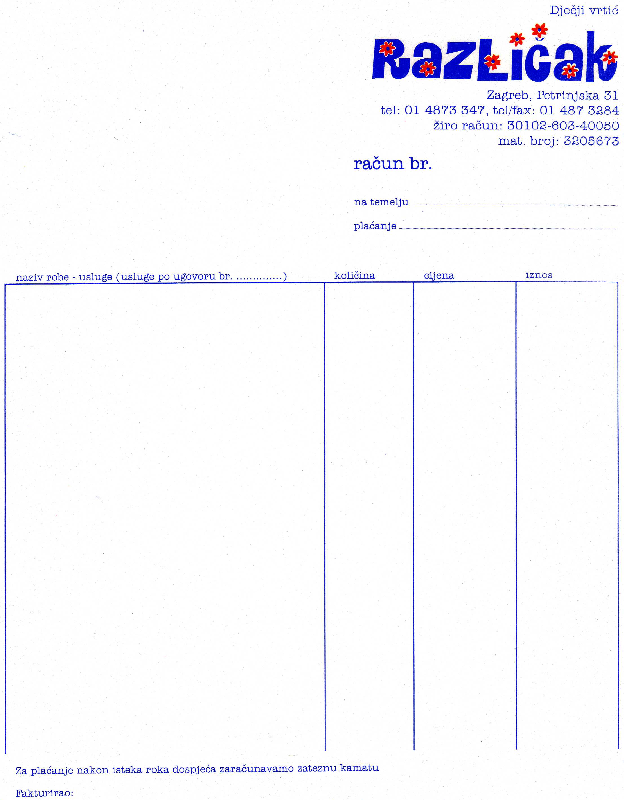
Petrinjska 31/2, Zagreb
tel.48 73,283
fax.48 70,520
www.razlicak.zagreb.hr
mail: vrtic.razlicak@zagreb.hr
Kindergarten "Različak" is placed in the center of Zagreb since the 1. July 1992. The year 1869. as the beginning of activity within preschool education, makes us special because we nursery with the longest history in the City of Zagreb.
Located at six different places in Zagreb in our daycare there are 545 children age one to six. The children are placed in 23 educational groups. About children in kindergarten cares 83 employees, of which 46 teachers and five members of the expert team: the principal, pedagogue, psychologist, educator for children with special needs and nurse.
The development of the key areas of quality are designed through collaborative learning of all stakeholders responsible for the quality of the educational process, and the culture of the whole kindergarten. Development Plan of the kindergarten follows our vision: "Različak - Kindergarten Equal Opportunities for All", which is aimed at strengthening the capacity of educational workers, raising the level of professional competence in different areas, standardization of quality levels and activity, and raising the level of autonomy through a common mission. Curriculum development is a strategic goal of kindergarten, such as monitoring and evaluating how the kindergarten grows.We also have been involved, as well as through self-evaluation in the pilot project NCVO to parcipate in research preeschool education in Croatia. Clear to us and starting points and goals, investing in our own resources and improving the quality with thoughtful planning, we are monitoring and evaluating the process by itself. These outcomes are compatible with the financial and human resources.
Since the development strategy of kindergarten is based on real compliance of vision, mission and commitment, it is based on common agreed values. Among others, it is the development of intercultural relations, multiculturalism and multi-ethnicity. Involvement in projects such as this one, is a sign of openness and proactivity.
Sincerely,
The principal
Sanja Hukavec

