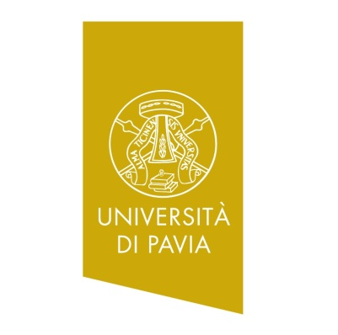
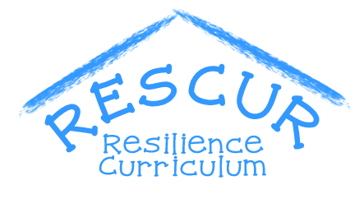
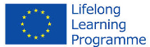

ITALIAN SCHOOLS

KINDERGARTEN SCHOOLS
NAME OF THE SCHOOL:
ISTITUTO COMPRENSIVO DI RIVANAZZANO TERME - SCUOLA DELL’INFANZIA PLESSO DI RETORBIDO
ADDRESS
PIAZZA ROMA, RETORBIDO (PV) - ITALY
THE CURRICULUM AIMS TO ENHANCE THE "INVISIBLE COMPETENCES" NAMELY CITIZENS SKILLS. LEARNING IS A PROCESS TO DEVELOP TALENTS OF EVERY STUDENTS. OUR SCHOOL CREATES OPPORTUNITIES TO SUPPORT INDIVIDUAL INTERESTS PROMOTING A LEARNING ENVIRONMENTS TO TAKE CARE OF THE WHOLE SCHOOL PATH OF CHILDREN IN THE PRESENT AND IN THE FUTURE.
CONTACT DETAILS
TELEPHONE: +39 0383 374472
EMAIL: INFANZIARETORBIDO@LIBERO.IT
WEBSITE: WWW.ISTITUTOCOMPRENSIVORIVANAZZANO.GOV.IT
LOGO
NUMBER OF STUDENTS :24
NUMBER OF TEACHERS : 3 (1 FULL TIME, 2 PART-TIME) + TEACHER OF CATHOLIC RELIGION

NAME OF THE SCHOOL:
ISTITUTO COMPRENSIVO DI RIVANAZZANO TERME - SCUOLA DELL’INFANZIA PLESSO DI SALICE TERME
ADDRESS
VIA E GENNARO, n. 17 - SALICE TERME (PV) - ITALY
THE CURRICULUM AIMS TO ENHANCE THE "INVISIBLE COMPETENCES" NAMELY CITIZENS SKILLS. LEARNING IS A PROCESS TO DEVELOP TALENTS OF EVERY STUDENTS. OUR SCHOOL CREATES OPPORTUNITIES TO SUPPORT INDIVIDUAL INTERESTS PROMOTING A LEARNING ENVIRONMENTS TO TAKE CARE OF THE WHOLE SCHOOL PATH OF CHILDREN IN THE PRESENT AND IN THE FUTURE.
CONTACT DETAILS
EMAIL: INFANZIASALICETERME@LIBERO.IT
WEBSITE: WWW.ISTITUTOCOMPRENSIVORIVANAZZANO.GOV.IT
LOGO
CLASSES AND NUMBER OF STUDENTS INVOLVED
3 CLASSES: A :28, B:28, C:29
NUMBER OF TEACHERS INVOLVED: 9

NAME OF THE SCHOOL:
ISTITUTO COMPRENSIVO DI RIVANAZZANO TERME - SCUOLA DELL’INFANZIA PLESSO DI CODEVILLA
ADDRESS
VIA ROMA, N. 32, CODEVILLA (PV) - ITALY
THE CURRICULUM AIMS TO ENHANCE THE "INVISIBLE COMPETENCES" NAMELY CITIZENS SKILLS. LEARNING IS A PROCESS TO DEVELOP TALENTS OF EVERY STUDENTS. OUR SCHOOL CREATES OPPORTUNITIES TO SUPPORT INDIVIDUAL INTERESTS PROMOTING A LEARNING ENVIRONMENTS TO TAKE CARE OF THE WHOLE SCHOOL PATH OF CHILDREN IN THE PRESENT AND IN THE FUTURE.
CONTACT DETAILS
EMAIL: INFANZIACODEVILLAO@LIBERO.IT
WEBSITE: WWW. ISTITUTOCOMPRENSIVORIVANAZZANO.GOV.IT
NUMBER OF STUDENTS : 28
NUMBER OF TEACHERS : 3 (1 FULL TIME, 2 PART-TIME) + TEACHER OF CATHOLIC RELIGION

