Creative problem-solving
and decision making

Children are natural problem solvers. During childhood all the settings where children interact with one another and participate in problem solving and decision making offer opportunities for children to grow.
The following pages present ideas for activities that you may wish to cover focusing on creative problem solving and decision making, helping children to learn different kinds of thinking (creatively, critically, rationally), problem solving strategies and taking decisions in order to take an active and positive role in their world.
Creative problem-solving involve the ability to plan, think alternatively, find solutions, reflect, before and after taking decisions, either individually or in groups.
The ability to think involves identifying beliefs, attitudes and feelings - positive thinking in problem situations (opportunity, optimism, self-efficacy, and efficiency) instead of having thoughts that don’t help (doubt having the skills, threat, low frustration).
Problem solving skills include problem identification, the generation of alternatives, finding and putting into practice a solution and evaluating its success.
Solving your own problems is part of growing up and taking responsibility for yourself. The more you learn to solve your own problems, the better you will feel about yourself, and your parents and teachers will also appreciate that you are becoming more self-reliant. Learning to solve your own problems doesn’t mean that you can’t ask for help. If you get stuck trying to solve a problem, it is fine for you to ask someone you trust to help you. (Introduction to problem solving unit for children workbook and/or parents manual – How to approach the theme with an accessible language)

Learning goals
By the end of the creative problem solving and decision making unit children will:
- recognize that all problems have solutions: be aware that everyday problems can have more than one solution (
- understand and apply problem orientation skills: be aware that we can have positive or negative beliefs, atitudes and feelings, but the positive ones will generally help more to reach solutions
- understand and apply problem solving and decision making skills: know about problem identification, generation of possible solutions through alternative creative thinking, decision making through consequencial thinking, implementation and evaluation of the solution. If the first solution reach success congratulate, savour and enjoy it, but if not don’t give up, take it easy, relax and try again.
Learning Outcomes Early Years (3-5/6 years old)

TIPS FOR THE TEACHERS

- Children should have opportunities to explore different possibilities in their everyday activities (play, interacting), reinforcing that sometimes there are not only wright or wrong solutions

- help the children to think before acting when facing a problem situation

- use everyday problems in the classroom to apply the problem solving orientation skills and F.A.S.T. problems solving strategies

- promote and help to collect information in order to best understand problems

- apply decision making implementation and evaluation skills

By the end of the unit I:

- can name my everyday problems
- I can solve my problems by myself or by asking help
- know there are solutions that I feel good with and others bad
- can choose the best solution and try it
- know F.A.S.T. problem solving strategy and I can apply it
Outcomes Early Primary (6/7-8/9 years old)
By the end of the unit I :
- can name everyday problems (mine or my peers) (identify and collect information to understand them better)
- know I can solve my problems in a better way if I think that I can find a solution
- can think of several and different solutions for my problems
- can make decisions choosing the best solution (the one that I and others feel better with).
- can put the solution into action and see if the results are good (or do it again until I'm happy with the results).
- know F.A.S.T. problem solving strategy and can apply it

Outcomes Late Primary (9/10-11/12 years old)
By the end of the unit I :
- can name everyday problems (mine or my peers) (identify, collect information, analyse barriers and facilitators, divide the problem in smaller parts if necessary, set problem solving goals)
- know I can think about my problems in positive and negative ways, but I believe that I can solve my problems in a better way if I think positive (challenge, optimism, self efficacy, commitment, efficiency)
- can think of several and different solutions for my problems (not forgetting the quantity, quality, possibility to combine different solutions and suspend judgement)
- can make decisions (elect the best solution based on the antecipation of the possible consequences of each alternative) and the goodness of the consequences (values, potential to solve the problem, time and effort required, change in personal and social well being).
- implement, evaluate the results on problem solving and if necessary do it again and again until I reach success.
- know brief F.A.S.T. problem solving strategy and can apply it

Early Years
(3-5 years old)
Level: Basic
Activity: The Right Questions
Objective: Work on different steps of problems solving, namely identification (through information collection), solutions generation (through alternative thinking), and decision-making (through the election of the best solution based on the feelings about each of the possibilities)
Materials: Common objects like a pencil, a box, a toy, a book…
Description:
- Talk to children about the importance of getting the information that they need to do something or to solve problems.
- Sometimes is necessary to know more about the problems (what’s going on). Sometimes we have to pay attention and to look for information.
- One child at a time can start to choose one colour, one type of object, or one shape, and try to discover the highest possible number of that element in the room (ensure that all children participate).
- Now, let’s try again a similar game but choose an object at random and hide it without the children’s seeing the object being hide.
- The children’s should discover which object was hidden, making only 10 questions.
- Guide children’s to question about the characteristics of the objects (size, color, shape, weight, smell, movement, sound ...).
- If they think they know what the object is, children’s may try to guess.
- Now talk to children about the importance of paying attention to their surroundings, the others, and yourself to better state “what is the problem?”.
- Explain the children, that after recognizing the problem it is very important to use your ability to think in different ways to solve the problem.
- Say that now we are going to try a new game to find different ways to use that object.
- Choose an object of the room and ask one children to think and say all things that he can do with that object. When he can’t think about more things to do, encourage him to ask for help from a classmate. Try that everyone participate at least with one “solution” across the activity.
- Count how many uses were found for that object and explain to the children that sometimes it’s possible to find much more uses then we could thought initially.
- Ask about how they feel when they do each of those (or some of those things) with that object.
- Ask them about what they like most to do with that object.
- Make the transfer to everyday problems, where sometimes we need to collect more information or ask questions to identify problems better, as well as think about different things that we can do to solve the problems and think about how we feel about that to choose the best one.

Learning Outcomes: By the end of this activity, I will be able to know that I need to ask questions to know more about things that are happening. I will be also able to know that there are many solutions that I can think about (some I feel good with/I like, some I feel bad/I dislike) but I can also ask for help to find more.

Level: Intermediate
Activity: Learning with the puppets
Objective: Work on different steps of problems solving, namely identification (of the feelings involved), solutions generation (through alternative thinking), and decision-making (through the election of the best solution based on the feelings about each of the possibilities)
Materials: Puppets (see in attachment?)
Description:
- Talk to children about the importance of identify and collect information related to different common situations. Through observation of practical situations, it’s easier to understand the problems.
- With finger puppets the teacher will tell the following story:
“Once upon a time, John and Daisy were doing a marvellous trip in a huge boat. They could see wonderful countries with marvellous places to visit. One night a huge storm with very strong winds and big waves broke the boat. So they needed to go to an island in the middle of the ocean. Fortunately they had enough food and they were also with their parents so they were not alone. But all communication were lost. So they needed to search for new ways to entertain themselves until someone come and rescue them. The first day was ok. The second too. But then they got bored. John would like to play soccer with his team but he has no one to play with. Daisy misses her friends. What could they do?”
- The story should be interactive given that the teacher ask for the identification of the problem (what is going on?; how are they feeling?, what can they do?, how would they feel about the solutions?, what is the best solution?, I would they feel after try the best solution?).

Learning Outcomes: By the end of this activity, I will be able to know more about how to solve problems: I should understand how I feel about the problem, think about different solutions for the problem and decide which the best solution is.

Level: advanced
Activity: “I can solve problems FAST”
Objective: Work on FAST problems solving strategy, namely know the strategy and how to apply it.
Materials: Sheets of paper, color pencils
Description:
- Ask for the children to tell about any problem. For example the cat/dog disappeared; the boy that wanted to have lots of chocolate before dinner, the girl that did not want to go to sleep, the coming to the new kindergarten, mum have to go away to work.
- Talk to the children about how they felt. Tell them that it is natural to be afraid, angry, sad. But then we can change our thoughts and use them to solve the problem. One important thing is to use a word to help us doing things in steps: FAST (Freeze, Alternatives, Solutions, Try).
- Let the children use the sheet of paper with the word FAST and paint it as they wish.
- Gather the children together, and let those who want to share their illustrations.
- Ask them if anybody would like to talk about a problem they can remember or happened a long time ago? Tell them this is the first step to solve the problems: Freeze – Stop and think about the problem (ask about feelings involved when they face that problem).
- On the sheet of paper the children can reflect through drawings the possible solutions for the problem. Tell them this is the second step to solve problems: think about alternatives (ask how they feel about each of the alternatives).
- Ask them to choose a solution for the problem. Tell them this is the third step to solve problems: choose the best solution (ask why that solution was the one that was choosen).
- Invite children to expose their drawings in the walls of the classroom.
- Ask if someone wants to role-play the situation and, if necessary, invite some friends to do it together. Tell them this is the fourth and last step to solve problems: try the solution (ask to each one how they feel with the problem solved).
If possible, it would be interesting to have cartoons with possible solutions to choose and some blank to fill
Homework: let the children record in a painting or asking their parents about a problem . ????? Follow this up, and let those who want to tell their problems solving to the group.
How to articulate homework with parents manual? Homework for every activities?

Learning Outcomes: By the end of this activity, I will be able to apply FAST problem solving strategy. I know that first I need to stop and think (Freeze); in second place I need to think about the solutions to solve the problem (Alternatives), in third I’m going to choose the best one (Solutions), and finally I’m going to do it (Try). I know also that I must look at my feelings about the problem and about each solution to choose the best one.

Early Primary
(6-8 years old)
Level: Basic
Activity: “I can solve problems FAST”
Objective: Work on FAST problems solving strategy, namely know the strategy and how to apply it.
Materials: Sheets of paper, color pencils
Description:
- Ask for the children to tell about any problem. For example the cat/dog disappeared; the boy that wanted to have lots of chocolate before dinner, the girl that did not want to go to sleep, the coming to the new kindergarten, mum have to go away to work.
- Talk to the children about how they felt. Tell them that it is natural to be afraid, angry, sad. But then we can change our thoughts and use them to solve the problem. One important thing is to use a word to help us doing things in steps: FAST (Freeze, Alternatives, Solutions, Try).
- Let the children use the sheet of paper with the word FAST and paint it as they wish.
- Gather the children together, and let those who want to share their illustrations.
- Ask them if anybody would like to talk about a problem they can remember or happened a long time ago? Tell them this is the first step to solve the problems: Freeze – Stop and think about the problem (ask about feelings involved when they face that problem).
- On the sheet of paper the children can reflect through drawings the possible solutions for the problem. Tell them this is the second step to solve problems: think about alternatives (ask how they feel about each of the alternatives).
- Ask them to choose a solution for the problem. Tell them this is the third step to solve problems: choose the best solution (ask why that solution was the one that was choosen).
- Invite children to expose their drawings in the walls of the classroom.
- Ask if someone wants to role-play the situation and, if necessary, invite some friends to do it together. Tell them this is the fourth and last step to solve problems: try the solution (ask to each one how they feel with the problem solved).
If possible, it would be interesting to have cartoons with possible solutions to choose and some blank to fill
Homework: let the children record in a painting or asking their parents about a problem . ????? Follow this up, and let those who want to tell their problems solving to the group.
How to articulate homework with parents manual? Homework for every activities?

Learning Outcomes: By the end of this activity, I will be able to apply FAST problem solving strategy. I know that first I need to stop and think (Freeze); in second place I need to think about the solutions to solve the problem (Alternatives), in third I’m going to choose the best one (Solutions), and finally I’m going to do it (Try). I know also that I must look at my feelings about the problem and about each solution to choose the best one.

Level: Intermediate
Activity: The novel Ball
Objective: Work on different steps of problems solving, namely solutions generation (through alternative thinking) and decision-making (election of the best solution that they feel better about it).
Materials: one ball; cards for the story (contexts: beach, mountain, city; characters: child, adolescent, young lady, old man; problems: natural catastrophes, an old house, an ambulance).

Description:
- Talk to the children about the importance of finding new ways of solving the same problem situation.
- It’s important to innovate and think differently, even when it seems impossible.
- Children make a circle.
- Give the ball to one of the children.
- Explain that in the first round, the group must decide the order in which the ball will move from children to children.
- Some rules: the ball can’t pass to the child that is immediately next to him/her; each child only receives and pass the ball one time (the first round ends when the ball had pass by all children).
- When the first round is complete, explain to the group that now the main goal is to pass the ball in the same order but increasing the speed.
- The ball can’t fall on the floor if it fall the round should start again. The ball always follows the order defined in the first round by children.
- Give some time for children to do several rounds. Tip: You can measure time that the group takes in each round.
- Give feedback and ask the group “if they could get better?"
- When it appears that the group can no longer do it faster to reduce the time of the round, ask what they can do to improve? What is the solution?
- Some solutions may arise and ideas to give clues: the group must be as near as possible; exchange position and place themselves organized in the order they chose at the beginning; forming a little ramp with hands, putting the palms facing up together and side by side, making a slight inclination towards the ball rolling.
- Try different solutions and evaluate the results.
- Reflect on what they learned. Reinforce the idea that with creativity and a different look on the situation, they they can find different solutions to the same problem.
- Now propose a new game. In this game, the class in a circle (like the previous one) should create a story where each child should participate in the development of the story. Say to them that all stories have problems, but also solutions, and now they are going to create a story where a character is having some troubles and you are going to help him to find a happy ending to the story. Pick a wool-novel and start with the story saying “Once upon a time… “. Pass the wool-novel to a child that should pick a card (see below) and continue the story based on the card (character). Then he passes the novel to the second child that picks another card (context), and again continues the story adding the new element in the card. The same happens with the third (card with the problem). All the children should participate in the development, helping to clarify the problem, to think of solutions, choosing one and evaluate (the story must have a happy ending).

Learning Outcomes: By the end of this activity, I will be able to find different solutions to solve them, and I to try them in order to decide about the one that is best to solve the problem.

Level: Advanced
Activity: The great detective
Objective: Work on different steps of problems solving, namely identification (of everyday problems), problem orientation (positive orientation) solutions generation (through alternative thinking), and decision-making (election of the solution that they feel better about it).
Materials: sheets of paper, glue and a camera
Description:
- Talk to the children about having a problem. Tell them that sometimes a problem means that we feel bad things, threat, frustration, anger, … because we don’t know how to solve it. But we know that we can solve our problems in a better way if we think that we can find a solution (reinforce this point). And there are always several solutions that I can think about and choose. Sometimes I can’t see any solution and in that case I can ask to someone. In other cases the solution doesn’t work and in that case, I will try a different way, we can think let’s try again, and so on.
- Introduce a practical and fun situation: The human knot, try in pairs to unknot the rest of the pupils.
- Make a circle. Put hands in the middle and hold others hands (not both hands of the same person). Now the group forms a big knot. The challenge is to unmake the knot without losing members hands. The group shall end in a big circle (two circles may be formed, according to the way hands are held).
- Talk to them about what had happening, the solutions that they had tried and the best solution.
- Make the transfer to everyday problems, giving an example: “I can’t find my favorite toy, what shall I do?”. What can I do? Cry, find another toy, ask mum to buy another one, …
- Let each child give examples of things that can be a problem.
- Summarize the examples (problems) and give to each pair (or group) a problem in a sheet of paper for them to think about the solutions and choose the best one.
- Write in the sheet of paper (or let them write or illustrate) the different solutions and best solution (the one that they feel better about it).
- Glue their photograph and write their names to a sheet of paper and write three positive things about the group as problems solvers (e.g. great detectives, Wow, so many solutions, amazing job) (Make sure that all the groups have an equal number of positive things said).
- Read each sheet of paper aloud so that all the children hear.
- Let the children show the sheets to their parents and let the parents add one positive thing about their child. (Make sure to follow this up.)

Learning Outcomes: By the end of this activity, I will be able to identify everyday problems (mine or my peers), to know that it’s easier a solution when I think that I can do it, choose the best solution, to find different solutions to solve them, and I will be also able to know that I can choose the best solution (the one that I and others feel better about it).

Late Primary
(9-11 years old)
Level: Basic
Activity: The great detective
Objective: Work on different steps of problems solving, namely identification (of everyday problems), problem orientation (positive orientation) solutions generation (through alternative thinking), and decision-making (election of the solution that they feel better about it).
Materials: sheets of paper, glue and a camera
Description:
- Talk to the children about having a problem. Tell them that sometimes a problem means that we feel bad things, threat, frustration, anger, … because we don’t know how to solve it. But we know that we can solve our problems in a better way if we think that we can find a solution (reinforce this point). And there are always several solutions that I can think about and choose. Sometimes I can’t see any solution and in that case I can ask to someone. In other cases the solution doesn’t work and in that case, I will try a different way, we can think let’s try again, and so on.
- Introduce a practical and fun situation: The human knot, try in pairs to unknot the rest of the pupils.
- Make a circle. Put hands in the middle and hold others hands (not both hands of the same person). Now the group forms a big knot. The challenge is to unmake the knot without losing members hands. The group shall end in a big circle (two circles may be formed, according to the way hands are held).
- Talk to them about what had happening, the solutions that they had tried and the best solution.
- Make the transfer to everyday problems, giving an example: “My best friend doesn’t talk to me?”. What can I do? Talk to him and ask what’s going on, ignore, get mad with him, …
- Let each child give examples of things that can be a problem.
- Summarize the examples (problems) and give to each pair (or group) a problem in a sheet of paper for them to think about the solutions and choose the best one.
- Write in the sheet of paper (or let them write or illustrate) the different solutions and best solution (the one that they feel better about it).
- Glue their photograph and write their names to a sheet of paper and write three positive things about the group as problems solvers (e.g. great detectives, Wow, so many solutions, amazing job) (Make sure that all the groups have an equal number of positive things said).
- Read each sheet of paper aloud so that all the children hear.
- Let the children show the sheets to their parents and let the parents add one positive thing about their child. (Make sure to follow this up.)

Learning Outcomes: By the end of this activity, I will be able to identify everyday problems (mine or my peers), to know that it’s easier a solution when I think that I can do it, choose the best solution, to find different solutions to solve them, and I will be also able to know that I can choose the best solution (the one that I and others feel better about it).

Level: Intermediate
Activity: The great journey
Objective: Work on different steps of problems solving, namely identification, orientation, solutions generation, decision-making and implementation and evaluation.
Materials: The great journey game (see in the end of the document)
Description:
- This activity consists in a board game that includes the five stages (identification, orientation, solution generation, decision-making, implementation and evaluation. Each stage has a different number of houses in order to work on different aspects of them.
- The game can be played by teams (4 to 5 teams of 3 to 4 children’s).
- An extra team, the judge team (with 2 to 4 children’s and the teacher?) is necessary to play the game.
- All the teams’ departure from the first house. ?
- When the team stops in one house, it should pick one card (of the pile that is in center of the board) and read the instructions that correspond to the stage where the team is (identification, orientation, …) and after that read the instruction of the house and give the answer or perform the action.
- The answer/performance is evaluated by the judge team that attributes a score from 1 to 3 (based on the fit, creativity, number of alternatives/questions/data/consequences, …)
- The number of houses that the team moves forward corresponds to the score attributed by the judge team.
- The first team to reach the end is the winner team.

Learning Outcomes: By the end of this activity, I will be able to identify and analyze problems (collect information, analyze barriers and facilitators, divide the problem in smaller parts if necessary, set problem solving goals); think about my problems in positive way (challenge, optimism, self-efficacy, commitment, efficiency); think of several and different solutions for my problems (not forgetting the quantity, quality, possibility to combine different solutions and suspend judgment); can make decisions (elect the best solution based on the anticipation of the possible consequences of each alternative) and the goodness of the consequences ( values, potential to solve the problem, time and effort required, change in personal and social wellbeing); try the solution and evaluate the results on problem solving and if necessary do it again and again until I reach success. (too many, complex…)
Level: Advanced
Activity: The problem box
Objective: Work on different steps of problems solving, namely identification, orientation, solutions generation, decision-making and implementation and evaluation through real problems given by the children’s.
Materials: A box, little pieces of papers, pens or pencils
Description:
- Ask children to describe in a little piece of paper an everyday problem. It can be a problem that they are facing right now (or someone that they know), a problem that happened some time ago, or a problem that are expecting in the future. Tell them that the problems are anonymous. They shouldn’t write their names in the piece of paper (this part can be done previously, one or two weeks before the opening of the box, and there is no limit number of problems that each children can introduce in the box.
- Place the children’s in a big circle. Open the box and read the first problem.
- Start working on identification issues, asking them “what is the problem’”, “Do they need more information to clarify it?”, “what can block the identification of the problem?”, “what can facilitate the identification of the problem?”, “is it one problem or several problems?”, “what do you want with this problem solving?” (each one can answer one question).
- Open another problem and focus this time on orientation issues asking them “what can I win?”, “the problem has a solution?” “can I find a solution?”, “this problem requires time to solve it?”, “this problem require effort?” (ask one question to each children in the circle)
- Now, with another problem focus on solution generation through alternative thinking, asking them “think about different alternative to solve this problem” (reinforce quantity and diversity, and help them to suspend the judgment about the alternatives) (each one can answer one question).
- With another problem focus on decision-making through consequential think, asking them to think in one solution for the problem, and then the good and bad things about the solution, how good and how bad those things are, the time and effort required to put in action the solution, and how I and/or others will feel better with that solution (each one can answer one question).
- Then organize groups of 3 to 5 children.
- Finally pick the other problems and read them aloud and ask to each group to choose one of the problem to role-play.
- Ask them to include in their role-play the different stages of problem solving: identification, orientation, alternatives, decision making, implementation and evaluation.

OR
Read all the problems. Choose the more interesting ones, and work on the methodology for each problem.
Learning Outcomes: By the end of this activity, I will be able to identify and analyze everyday problems (collect information, analyze barriers and facilitators, divide the problem in smaller parts if necessary, set problem solving goals); think about my problems in positive way (challenge, optimism, self-efficacy, commitment, efficiency); think of several and different solutions for my problems (not forgetting the quantity, quality, possibility to combine different solutions and suspend judgment); can make decisions (elect the best solution based on the anticipation of the possible consequences of each alternative) and the goodness of the consequences ( values, potential to solve the problem, time and effort required, change in personal and social wellbeing); try the solution and evaluate the results on problem solving and if necessary do it again and again until I reach success. (too many, complex…)

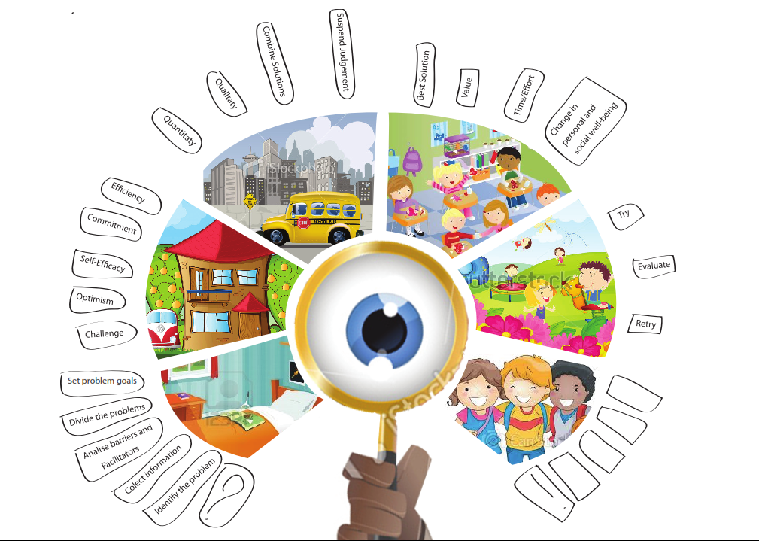

The Great Journey

5 categories: Identification, Orientation, Alternatives, Decision-making, Implementation & Evaluation

Identification:
Identify the problem
- What’s going on?: what is the problem?
Collect information
- Detective in action: what clues/questions do I need to search/ask to understand the problem?
Analyse barriers and facilitators???
- Angels and Devils (or fairies and witches… or…): who/what can help me to see/clarify the problem and who/what doesn’t let me to see/clarify the problem
Divide the Problems
- Too complicated?: is it one problem or several problems?
Set problem goals
- Why am I doing this?: I want to solve this problem to… (or because… )

Orientation:
Challenge
- Challenge time: what can I win by solving this problem?
Optimism
- Every problem have solutions: Is it this one different… because?
Self-efficacy
- Yes, I can!: and I can solve this problem because, I am or I have…
Commitment
- Problem solving need time and effort: and this problem also need it because…?
Efficiency
- Solve it or not?: I will solve this problem because…

Alternatives:
Quantitaty
- Everything I can do: think in many alternatives as you can for this problem?
Quality
- Different must be different: Think in different ways to solve the problem
Combine solutions
- Sometimes two or three is better than one: think in two, or more solutions for the problem that can be combined…
Suspend judgment???
- Stop! There’s a time for everything… so don’t judge before time: listen the alternatives that your colleague provide to solve the problem (or don’t block the brainstorm in your head: think aloud in the alternative to this problem)

Decision-making:
Best solution
- Good versus bad: Name good things and bad things of each solution presented for the problem
Value
- Very good, very bad: how good or how bad are the things that can happen within this problem?
Time/effort
- Too many time and too much effort: Choose the best solution regarding time and effort economy
Change in personal and social well-being
- What changes: how these solutions help me or other to feel better?

Implementation & Evaluation:
Try
- 1…2…3… Action: try to put in action the best solution for this problem (role-play)
Evaluate
- Is it solved?: Evaluate the solution and the results (role-play)
Retry
- Need to do it again?: Observe the situation and the solution and decide if another solution is needed (role-play)
Cards
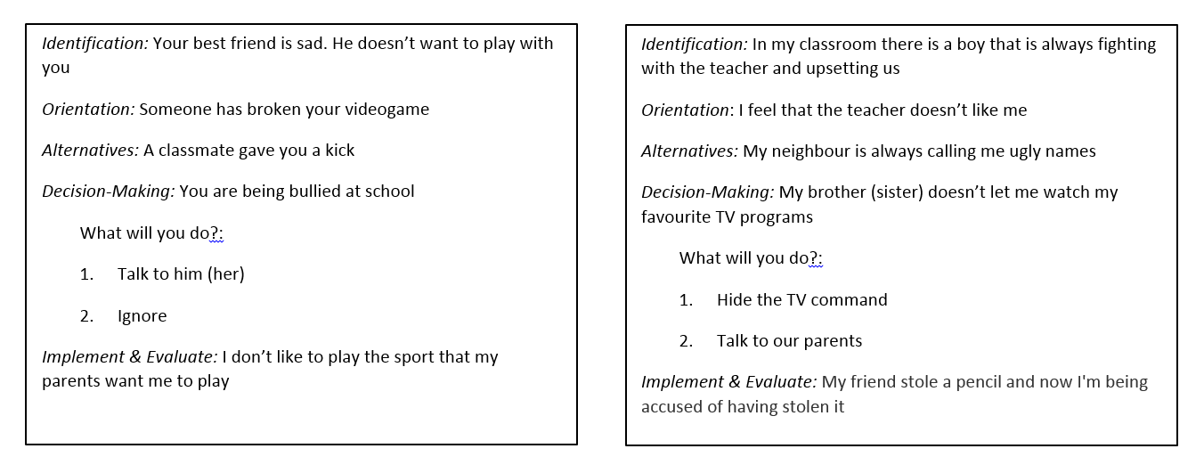
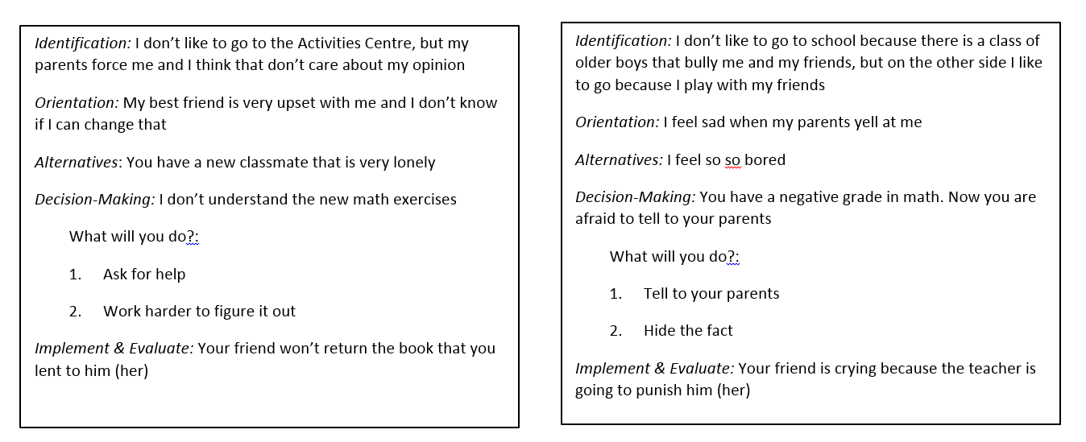
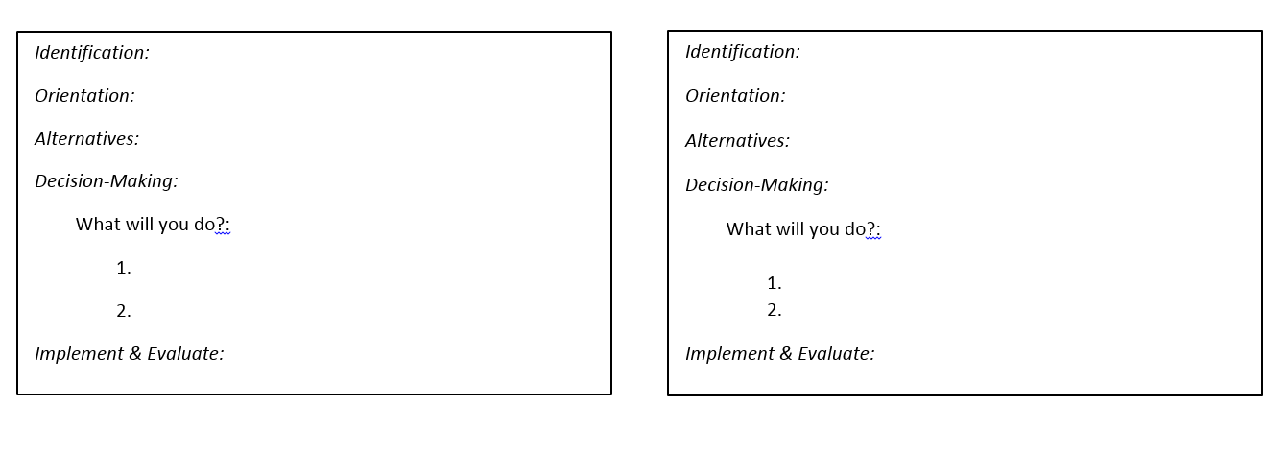
Identification:
Orientation:
Alternatives:
Decision-Making:
What will you do?:
1.
2.
Implement & Evaluate:
Identification:
Orientation:
Alternatives:
Decision-Making:
What will you do?:

Implement & Evaluate:

Identification:
Orientation:
Alternatives:
Decision-Making:
What will you do?:
1.
2.
Implement & Evaluate:
Identification:
Orientation:
Alternatives:
Decision-Making:
What will you do?:

Implement & Evaluate:
Identification:
Orientation:
Alternatives:
Decision-Making:
What will you do?:
1.
2.
Implement & Evaluate:
Identification:
Orientation:
Alternatives:
Decision-Making:
What will you do?:

Implement & Evaluate:
Identification:
Orientation:
Alternatives:
Decision-Making:
What will you do?:
1.
2.
Implement & Evaluate:
Identification:
Orientation:
Alternatives:
Decision-Making:
What will you do?:

Implement & Evaluate:

