 | “BUILDING HEALTHY RELATIONSHIPS” EVALUATION REPORT
21/01/2015 | Italian RESCUR team
INTRODUCTION | Valeria Cavioni  Maria Assunta Zanetti  Giusy Beddia  Mara Lupica Spagnolo  Department of Brain and Behavioral Sciences – Psychology University of Pavia (Italy)
The theme “Building healthy relationships” seeks to enable the children to develop such relationships in their healthy development and deal successfully with the challenges and stressors they are set to face in their lives. Many studies underlined that resilience is related with having positive and healthy social relationships with adults and peers (Werner, 1990). Much research has been carried out about the importance of this protective factor, suggesting that individuals who do not have a functional social support system are more vulnerable to stress and difficulties and less likely to cope effectively with adversity. Furthermore, having supportive relationships with one or more close friends is a protective factor against peer rejection itself (Bolger & Patterson, 2003). The quality of social relationships offer opportunities for children to feel socially accepted and loved or, when the quality of the social relationships is poor, it might foster a sense of vulnerability and obstruct healthy social and emotional development. The activities of the first subtheme “Establishing and maintaining healthy relationships” are designed to support the development of pro-social skills in order to create a strong network of positive relationships. They focus on key areas, namely: making and sustaining friendships seeking and providing support, nurturing relationships and a supportive and inclusive school climate. The second sub-theme titled developing cooperation skills and empathy and engaging in responsible and ethical behaviors is composed of activities to enhance cooperative skills, empathy and moral reasoning. Activities are organized for children to work together and cooperate to achieve the same goal, discussing the best way to undertake a task and ensuring that everyone actively participates. With the help of these activities children will learn, also, how to take others’ perspectives through social interactions with peers and critically reflect on their own moral arguments and ethics. Practicing ethical and responsible behaviours requires children to focus beyond the self, and develop intellectual and emotional honesty, and a willingness to confront and articulate their vulnerabilities in order to make necessary changes in their personal lives.
METHODOLOGY
The Italian teachers’ training and the implementation of the 5th theme involved 84 teachers from 17 kindergarten, primary and secondary schools from the areas of Milan and Pavia. At the end of the teachers’ training course an evaluation questionnaire to assess teachers’ satisfaction of the training course was administered.
Data collection of on the effectiveness of the piloting of the curriculum was performed using following instruments:
- children’s behavior questionnaire;
- focus groups with students;
- reflexive diary
- teachers’ interviews
Findings
Evaluation questionnaire of teachers’ training course
Table 1 displays a summary of findings collected from the teachers’ questionnaires of the training course.
Table 1 – Findings from the teachers’ training questionnaires
Section A: Your views on the organization of the training session
Satisfaction with the organization of the training session:
Features liked:
- Simplicity and clarity of contents
- Email communications and availability of the staff
- Availability and acceptance on teachers’ needs and problems
- Trainer knowledge and professionalism
Features need to be changed/improved:
- More time to implement the program
- Split teachers by children’s age
- Rooms not always comfortable
- More time to discuss with other teachers that implemented RESCUR
- More hours of teachers’ training
Content and Process of the training
What were the most helpful aspects of the training session?
- Topics such as: friendship, sharing, cooperation, empathy
- The possibility to choose activity between 3 levels of difficulty
- Direct assessment on the effectiveness of the pilot from teachers and students
- Experiential aspects during the teachers’ training
- Reflecting activities for children on their relationships with peers
- Contents of training referred to recent study in psychology
What were the least helpful aspects of the training session?
- Complexity of stories
- Some stories were not always easy to link with learning goals
- Few discussions between teachers during the training sessions
What improvements would you suggest for the future?
- To have more time to implement activities
- To continue the project
- More exchange of information on what happened in the other classes
- Disseminate the project over the Pavia province
- Provide suggestions for parents
- More hour in the teachers’ training course

Section B: Your views on the resilience curriculum
What are the main strengths of the curriculum programme?
- Deal with indispensable topics related to the harmonious and balanced development children
- Optimus explanations and easy written text of the manuals
- Opportunity to involve parents
- Available materials for children

What are the main weaknesses of the curriculum programme?
- Short time for the implementation
- Complexity of concepts for children
- Difficulty in the class management during the activities
- Having 3 levels can be difficult, it’s better to have just one level
- The program cannot be implemented for 3 years old children
- No practical tips

What modifications if any would you recommend in the curriculum?
- To review activities before the implementation considering individual teachers’ skills and knowledge

What issues do you foresee in the implementation of the curriculum in the classroom and how may these be addressed?
- Children’s exclusion from some activities (especially for 3-year-old children)
- Parents’ complains because these activities will take time from traditional teaching activities
- Difficulties in parents’ involvement
- Some teachers consider herself/himself not qualified to run these kind of activities

Children’s behavior questionnaires
Figure 1 shows frequencies of improvements expressed by teachers on the children’s behavior questionnaires. Findings clearly showed that the piloting of the activities had positive effects on children behavior.
Figure 1: Results of children behavior questionnaires over the past 6 weeks
Making and having friends | Seeking and providing support | Nurturing relationships and school climate
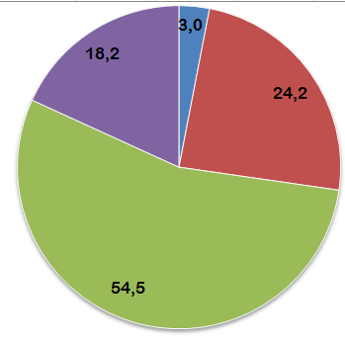 | 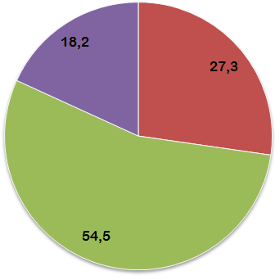 | 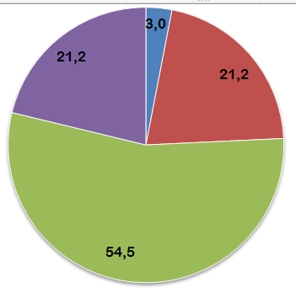
Sharing, cooperation and teamwork | Empathy | Ethical, responsible and moral behaviour
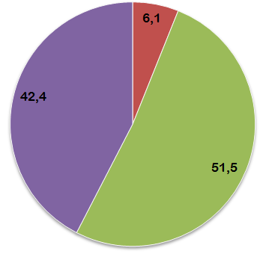 | 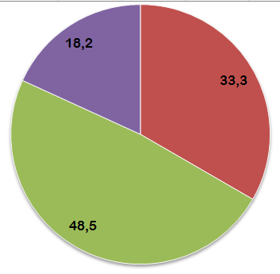 | 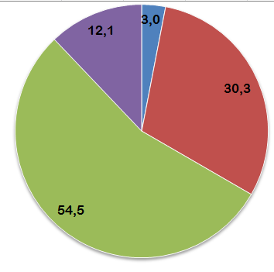
Key

Focus groups with children
Focus groups were conducted in 35 classes (for a total of 738 pupils, 348 males and 390 females) at the end of the implementation in order to seek children’s feedbacks regarding their experiences with the activities of the Italian’ theme. Data were collected by two methods: notes were taken by the facilitator and later transcribed, and drawings of mascots’ or significant stories were asked to children. The average time for discussion and drawings was 40 up to 90 minutes for each class.
The discussion was set to encourage conversation on main topics of the theme; students were asked their opinions and reflections on activities, materials and home activities. Photos of posters and students’ worksheets were taken at the end of the focus groups. Table 2 gives details of predefined questions and children’s answers and comments.

Table 2 – Children’s evaluation
Early years | Which activity or story did you like most?  - “Sherlock the squirrel needs to feel safe and happy”  - “I’m happy with you”  - “Peat’s fear”  Strengths and weaknesses of the activities  Children appreciated the possibility to play new game in the classroom, especially when they needed to dramatize the story.  They also liked parents’ involvement and the opportunity to expression emotions with parents.  During some activity, the expression of emotions was quite difficult, in particular in the activity named “I can feel your emotion”
Early Primary | Which activity of story did you like most?  - “Too different from Zelda”  - “Bees’ secret”  - “Sherlock meets a friend”  - “The poisoning mushroom”  What did you learn from this activity?  “Tt’s important to obey rules and help each other because then everything is easier and nicer”.  Strengths and weaknesses of the activities  Children liked activities because they had the chance to address interesting and unusual topic related to their daily school activity.  They enthusiastically participated with great discussions because they like team work with friends but also to could socialize with the other peers  Children were also happy parental involvement since it gave them a way to spend more time together.  No negative aspects were found. Few children were too emotionally involved watching a clip included in one activity, they said they didn’t like it a lot because they felt “bad” after it. The movie was selected to address the topic of empathy, in particular when others feel negative emotions when they face difficulties.
Late Primary | Which activity of story did you like most?  - A game to trust you  - Magic touch  - Playing relay races  What did you learn from this activity?  “I learned to put myself in someone else's shoes, to be useful and help others”  Strengths and weaknesses of the activities  The discussion showed that children responded positively to the activities, they learned to trust their classmates and to use these skills in their everyday life. Students were very happy for this opportunity, it help them to share their emotions with others, finding support and encouragement from the class’ group and from teachers. It was nice for them to work in team groups addressing topics that are usually not covered in the school curriculum.  Some children did not like some homework because they judged them too personal. These children suggested to create homework focused more of playing then reflecting with parents on an emotional topic.

Reflective diaries
All teachers fulfilled the diaries for each activity they run in their class responding very positively to the activities of the curriculum; furthermore they were able to involve their students from the beginning of the implementation.
From the contents of the diaries, teachers reported that students appreciated all stories and activities and they could build a sort of "pact of cooperation" between students and teachers.
Children were excited especially about working in groups and the homework. Children had the unique opportunity to work cooperatively with parents and discuss with them about what they learned at school.
An issue was raised on the required time to implement each single activity; because of the complexity of the topics, even a single activity needed at least 60 up to 90 minutes to be completed.

Teachers’ interview
An individual interview was run in order to collect general feedbacks on the programme. The teacher explained that the whole RESCUR project, namely teachers’ training and the implementation, was a precious tool to know more on her students. She also completed, throw the activities, the annual formative unit on “The self and the others”, according to the Italian guideline for kindergarten teachers.
Activities were very useful to give children the opportunities to “give a name to their feelings” and, in general, to talk about themselves. She reported that it was not common to use school time to listen to children’s relational and emotional needs and worries and this project provide the time for it. It was a great idea to present the 2 main characters (Sherlock and Zelda) for all stories, they became a sort of friends for pupils and children were able to create connections between Sherlock and Zelda’s adventures and their own life’s events.
Parents liked homework, they said it was really nice to do something together with their children and they were really disappointed when the project was over. Teachers said that she was going to keep this methodology also in the future.
She, finally, expressed some doubts on the possibility to run activities for 3 years old children, furthermore some activities required lot of time for discussions and, considering the large number of children in each class (28 average of number children), it was not easy to involve everybody.

Discussion and recommendations
In general, there was a positive consensus among all teachers related the quality of teachers’ training and the activities of the programme. Teachers appreciated the change to work on social and emotional aspect of development promoting resilience at schools. Most concerns highlighted that they would have preferred to have more time for the implementation and the difficulties to involve 3-years-old children.
It was interesting to discover, through children’s comments, that parents enjoyed the homework considering them as a further opportunity to help their children in the development of resilience skills. Similar, also teachers were very glad to be able to direct involve parents in the project.
It must be noted that a main issue was raised from many teachers on the timing of the activities as they required more time than planned.
The overall impression was that RESCUR activities represented a real and useful source of personal and professional enrichment to develop resilience not only for children and teachers, but also for families and the whole school community.

Appendix

Sample copies of the mascots produced by Italian children
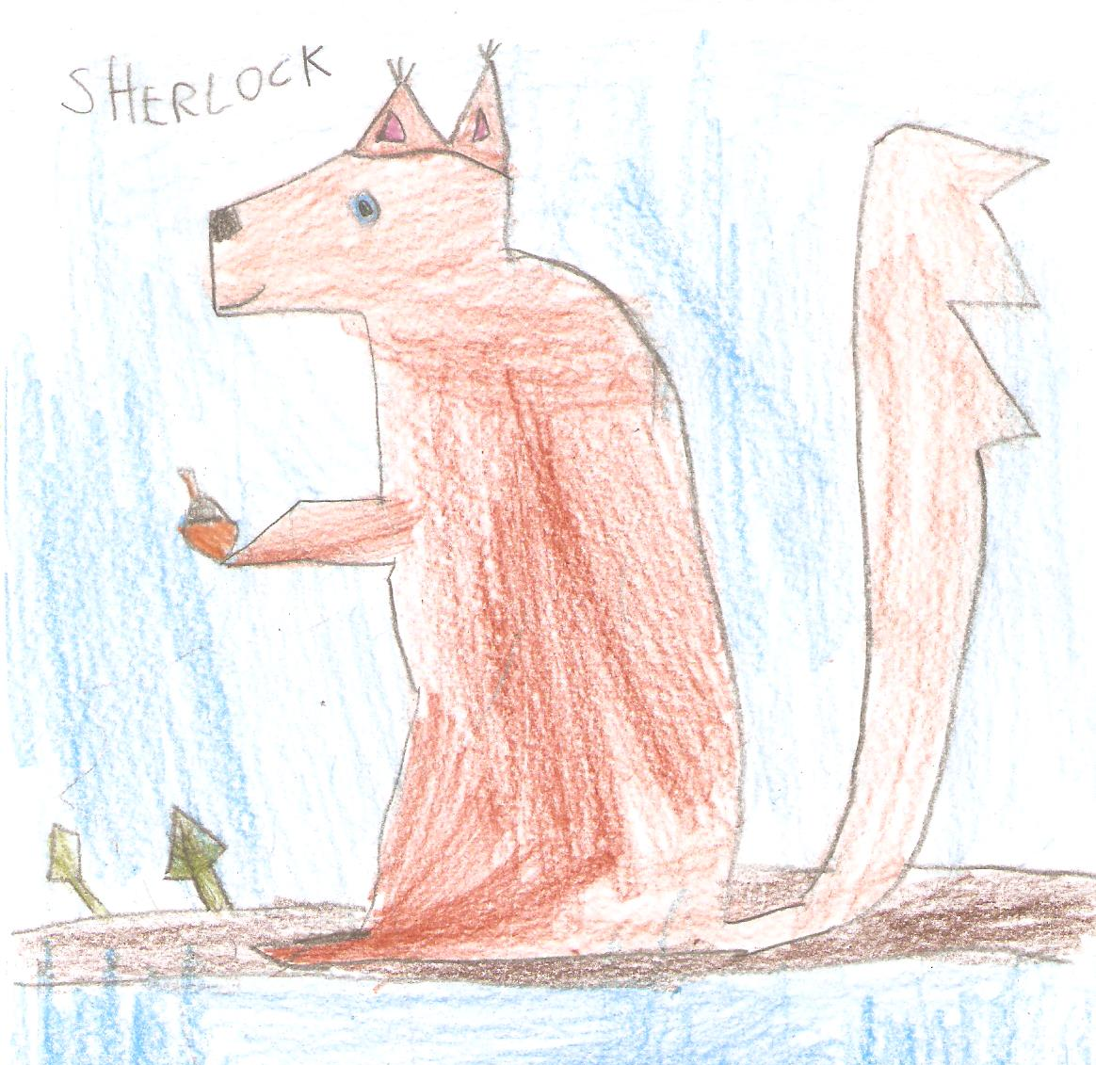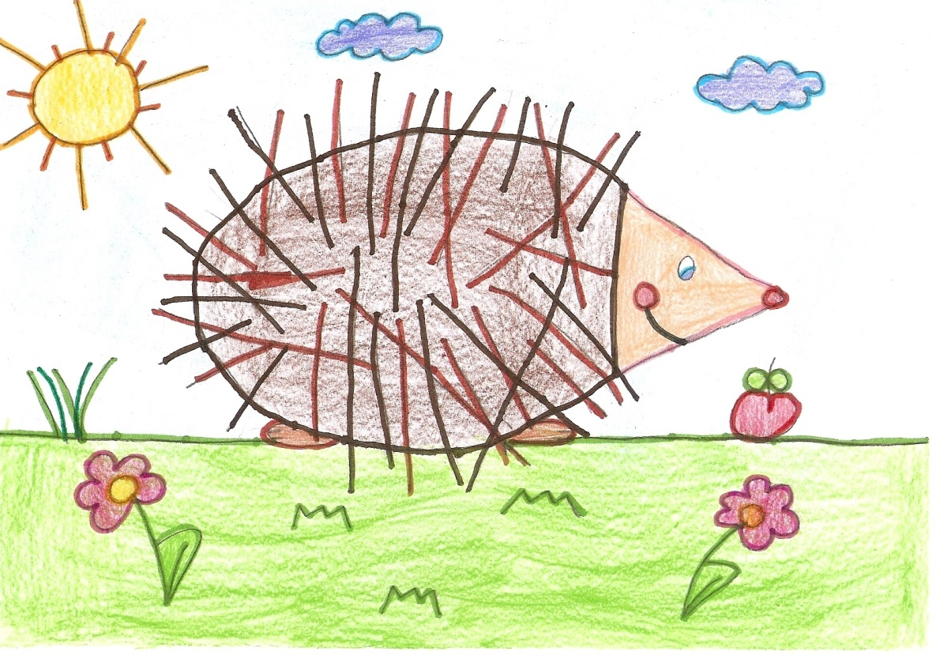

Photos from classroom’s activities
